智能手机数据分析报告

Data cleaning; Association rule mining;

Clustering Classification, Data reduction

**申明**

**本报告仅用于施文俊的简历中充当材料证明，部分内容因无法展示已进行了删除。**

**Introduction**

The project aims to help mobile phone manufactures to identify what kind of mobile phones can be sold at a high price. What features of a mobile phone should have so that customers would like to purchase at a high price. In order to identify those features, models are built based on SVM classifier and decision tree classifier. Two models are build based on the scaled data set.

In this project, there are six parts.

In the first part, data cleaning is made on the raw data set. We read and understand the meaning of each attribute in the table. Distinguishing each attribute’s type，discretizing some attributes for completing the next task. Then, testing and selecting the correlation of each variable with the target variable.

The second, third, and fourth parts are analyzed Association rule mining, classification, and clustering respectively. Through different analytic methods, we will explore which types of mobile phones produced by mobile phone manufacturers are easier to sell at high prices.

Data reduction is our fifth part. We perform numerosity reduction and attribute reduction. After selecting attribute again, we train the two classifiers in Task 3 again to explore the different results between original data and reduced data.

We compare with the three analytic rules (association rule mining, classification and clustering) and interpret their relations in the context of this problem in the last part.

**PART 1: Data cleaning and basic analysis …………………….. 4**

**PART 2: Associating rule mining ………………………………… 10**

**PART 3: Classification ……………………………………………… 15**

**PART 4: Clustering ……………………………………………….…. 23**

**PART 5: Data reduction …………………………………………….. 25**

**PART 6: Comparison and conclusion …………………………… 42**

**Assumptions**

1. In this project, all the data and features are relevant to the price of the mobile phone, all the other irrelevant data will be removed.
2. In the project, the features of the mobile phones are the only influencers to the price.

**Task1: Data cleaning and analysis**

**Data Overview**

In this project, one CSV file and one xlsx file will be used.

|  |  |  |
| --- | --- | --- |
| **File name** | **Overview** | **Main Contents** |
| mobile_price(csv) | 22 columns and 2000 rows | Id, features of mobile phone, phone price (high or low) |
| ColumnDescription(xlsx) | 2 columns and 22 rows | Column and explanation |

Table 1.1: Data overview

**Column description**

1. ID: The index of the mobile phone, which is not relevant to the mobile phones. This column will be removed in model building.

2. Based on the file “ColumnDescription”, all the features of a mobile phone in the “mobile_price” file are as follow:

|  |  |  |
| --- | --- | --- |
| **Index** | **Column** | **Explaination** |
| 1 | battery_power | Total energy a battery can store in one time measured in mAh |
| 2 | blue | Has bluetooth or not |
| 3 | clock_speed | speed at which microprocessor executes instructions |
| 4 | dual_sim | Has dual sim support or not |
| 5 | fc | Front Camera mega pixels |
| 6 | four_g | Has 4G or not. 1 = yes , 0 = no |
| 7 | int_memory | internal Memory in Gigabytes |
| 8 | m_dep | Mobile Depth in cm |
| 9 | mobile_wt | Weight of mobile phone |
| 10 | n_cores | Number of cores of processor |
| 11 | pc | Primary Camera mega pixels |
| 12 | px_height | Pixel Resolution Height |
| 13 | px_width | Pixel Resolution Width |
| 14 | ram | Random Access Memory in Mega Bytes |
| 15 | sc_h | Screen Height of mobile in cm |
| 16 | sc_w | Screen Width of mobile in cm |
| 17 | talk_time | longest time that a single battery charge will last when you are |
| 18 | three_g | Has 3G or not |
| 19 | touch_screen | Has touch screen or not, 1 = yes, 0 = no |
| 20 | wifi | Has wifi or not |

Table 1.2: Features of a mobile phone

1. price_category: This column contains “0” and “1”. It explains whether the mobile phone get a high price or not. 1 = yes, 0 = no.

**Uniform attributes**

1. battery_power:

This is a numeric data ranging from 501 to 1998. The mean value is 1238.51

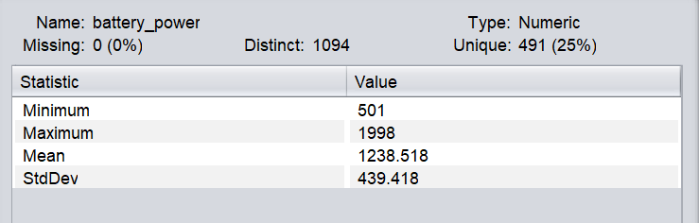

Picture 1.1: Feature “Battery_power”

1. blue:

This feature is categorical data. It contains “yes”, “no”,” has”,” not” in different capitalization.

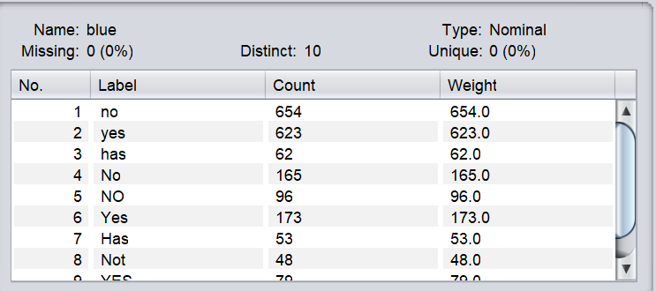

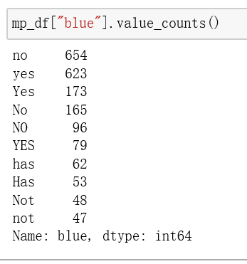

Picture 1.2: Feature “blue”

In order to unify all the attributes for model building, “yes” and” has” will be replaced by 1, while “no” and” not” will be replaced by 0.



Picture 1.3: Replacing “yes”, “no”,” has”,” not” with 1 and 0 for “blue”

After transformation, the feature only includes 0 and 1.

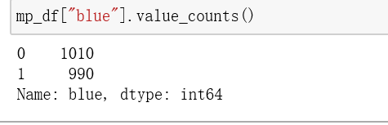

Picture 1.4: Feature “blue” after transformation

**Categorical and numeric Features**

In all, the features of mobile phones are as follow.

|  |  |
| --- | --- |
| **Categorical Features** | **Numeric Features** |
| blue | battery_power |
| dual_sim | clock_speed |
| four_g | fc |
| three_g | int_memory |
| touch_screen | m_dep |
| wifi | mobile_wt |
|  | n_cores |
|  | pc |
|  | px_height |
|  | px_width |
|  | ram |
|  | sc_h |
|  | sc_w |
|  | talk_time |

Table 1.3: Categorical and numeric Features

**Removing noise and outliers**

In this part, data cleaning is conducted to reduce outliers and extreme values in the data set. Interquartile Range function in Weka is used to search for outliers and extreme values.

The result suggests there are no outliers and extreme values in all the 2000 instances. There is no need to do noise cleaning for this data set.

**Determine relevance of mobile phone features with price**

In this part, analysis of the relevance of mobile phone features and phone prices are committed. Different plots are used to analysis the distribution of data. As to any feature, if there is no big difference between the distribution of high-priced and low-priced mobile phones, it means this feature is not very relevant to the mobile price. Reduction of attributes is not committed in this part.

Feature1: battery_power

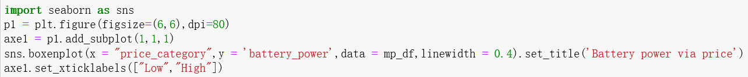

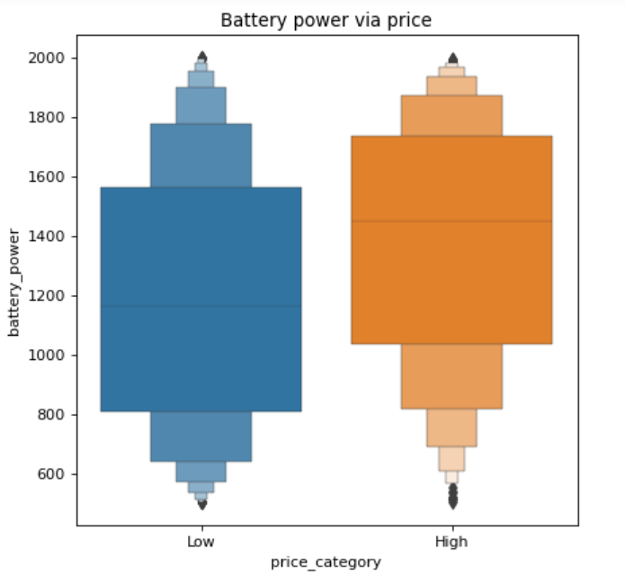

Picture 1.30: Battery power via price

According to the picture, the distributions of battery power are different via price. In comparison, high priced mobile phone has a high mean value of battery power. Through the distribution, we can find most of the priced mobile phone has large battery volume.

In conclusion, “Battery power” is definitely related to mobile price.

Feature2: blue

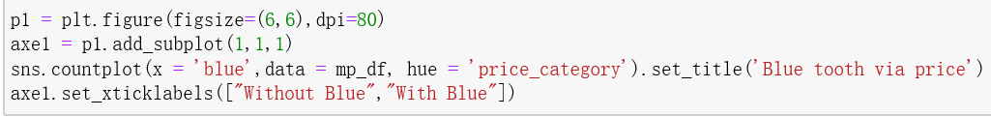

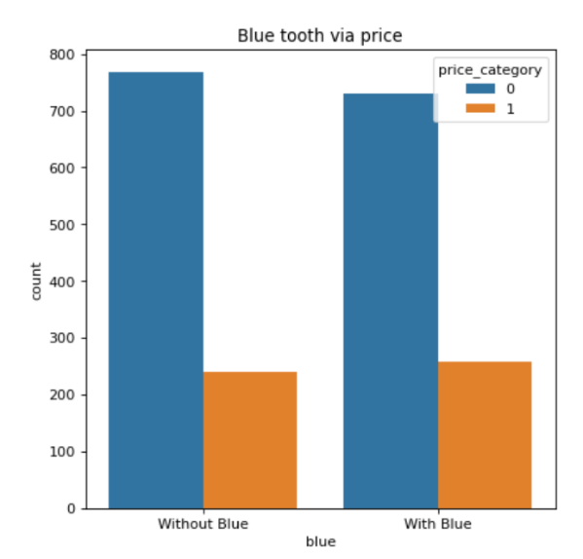

Picture 1.31: Blue tooth via price

In the picture, the distributions of plots for different priced mobile phone are quiet the same.

In conclusion, blue tooth is not relevant to mobile price.

In comparison, the ratios of wifi are similar for two different priced mobile phones.

In conclusion, wifi is not relevant to mobile price

|  |  |
| --- | --- |
| **Irrelevant Features** | **Relevant Features** |
| blue | battery_power |
| clock_speed | four_g |
| dual_sim | int_memory |
| fc | 4g |
| m_dep | mobile_wt |
| pc | n_cores |
| sc_h | px_height |
| talk_time | px_width |
| touch_screen | ram |
| wifi | sc_w |
|  | three_g |
|  | ram |

Table4: Relevant and irrelevant features

**Task 2: Association rule mining**

Association rule mining work better with discretized data, therefore we discretize the numeric attributes into four part and used them to conduct association rule mining.

2.1 Ranking degree of interesting of the rules

Select a subset of the attributes (or all the attributes) to mine interesting patterns. To rank the degree of interesting of the rules extracted, use support, confidence and lift.

1. **confidence**

Click on the Associate Tab, which will bring up the default association rule mining window.Click the Choose, which will bring up the parameter editor to allow to change minimum support and minimum confidence. Since I need to find the significant association, I changes the lowerBoundMinSupport to 0.25 and minMetric to 0.25 and click OK.

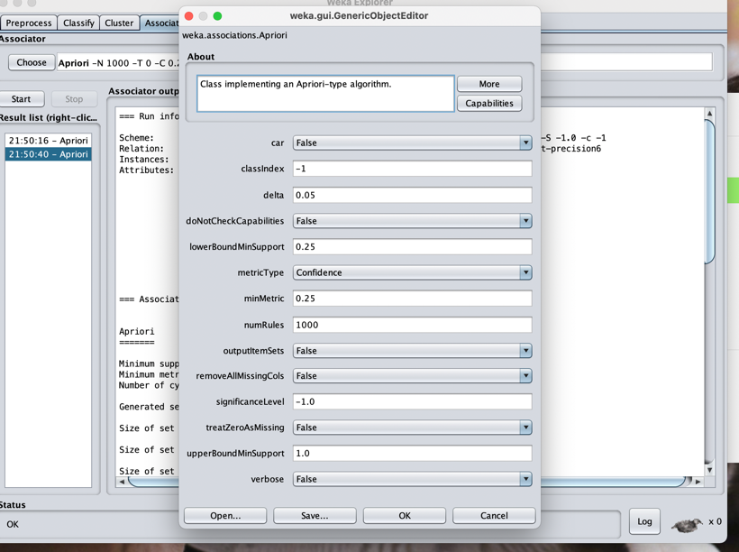

Picture 2.1.1

Then click the Start button to obtain the results below. Compare the rules discovered to rank the degrees.

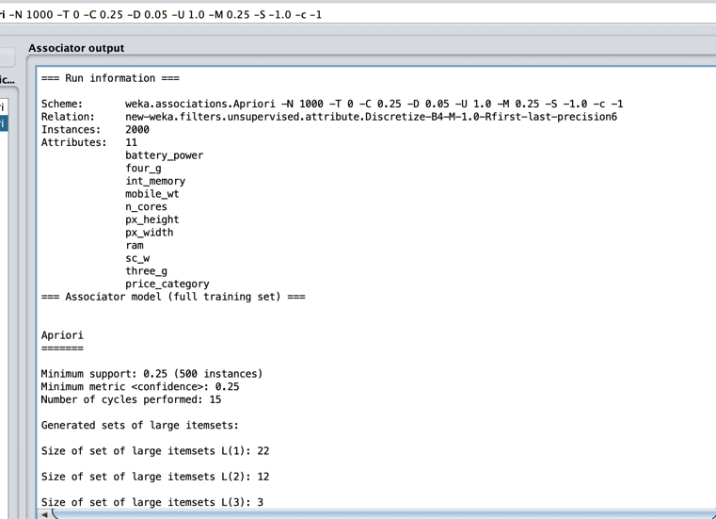

Picture 2.1.2

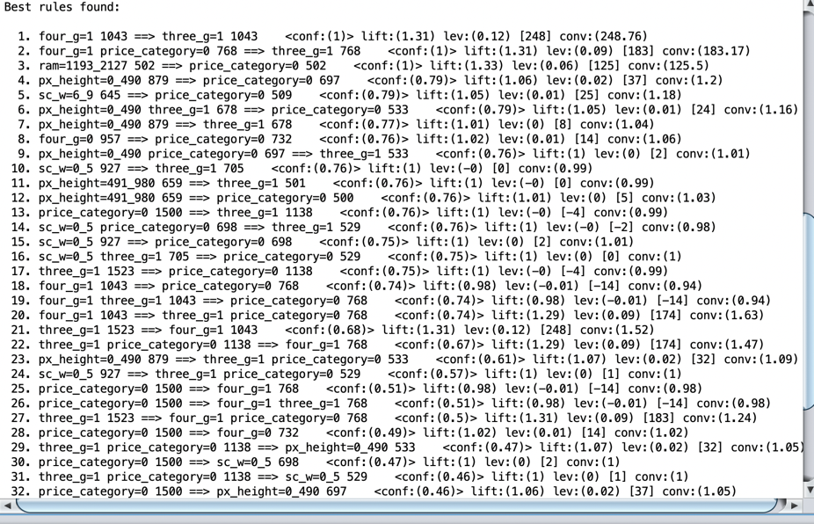

Picture 2.1.3

The result shows as bellow, it is ranked with confidence greater than 0.5:

According to the results of confidence , I ranked the degrees with confidence greater than 0.5：

1. four_g=1 1043 ==> three_g=1 1043 <conf:(1)>

2. four_g=1 price_category=0 ==> three_g=1 <conf:(1)>

3. ram=1193_2127 ==> price_category=0 <conf:(1)>

4. px_height=0_490 ==> price_category=0 <conf:(0.79)>

5. sc_w=6_9 ==> price_category=0 <conf:(0.79)>

6. px_height=0_490 three_g=1 ==> price_category=0 <conf:(0.79)>

7. px_height=0_490 ==> three_g=1 <conf:(0.77)>

8. four_g=0 ==> price_category=0 <conf:(0.76)>

9. px_height=0_490 price_category=0 ==> three_g=1 <conf:(0.76)>

10. sc_w=0_5 ==> three_g=1 <conf:(0.76)>

11. px_height=491_980 ==> three_g=1 <conf:(0.76)>

12. px_height=491_980 ==> price_category=0 <conf:(0.76)>

13. price_category=0 == three_g=1 <conf:(0.76)>

14. sc_w=0_5 price_category=0 ==> three_g=1 <conf:(0.76)>

15. sc_w=0_5 ==> price_category=0 <conf:(0.75)>

16. sc_w=0_5 three_g=1 ==> price_category=0 <conf:(0.75)>

17. three_g=1 ==> price_category=0 <conf:(0.75)>

18. four_g=1 ==> price_category=0 <conf:(0.74)>

19. four_g=1 three_g=1 ==> price_category=0 <conf:(0.74)>

20. four_g=1 ==> three_g=1 price_category=0 <conf:(0.74)>

21. three_g=1 ==> four_g=1 <conf:(0.68)>

22. three_g=1 price_category=0 ==> four_g=1 <conf:(0.67)>

23. px_height=0_490 ==> three_g=1 price_category=0 <conf:(0.61)>

24. sc_w=0_5 927 ==> three_g=1 price_category=0 <conf:(0.57)>

25. price_category=0 1 ==> four_g=1 <conf:(0.51)>

26. price_category=0 ==> four_g=1 three_g=1 <conf:(0.51)>

27. three_g=1 ==> four_g=1 price_category=0 <conf:(0.5)>

1. Lift

Click on the Associate Tab, which will bring up the default association rule mining window.Click the Choose, which will bring up the parameter editor to allow to change minimum support and minimum confidence. Since I need to find the significant association, I change lowerBoundMinSupport to 0.25 and minMetric to 1 and click OK.

For the values of lift, if lift is less than 1, then occurrence of A is negatively correlated with B; if lift is more than 1, occurrence of A is positively correlated with B; if lift is equal to 1, occurrence of A is independent of B. Based on those situations, I only select those classes which lift are more than 1.

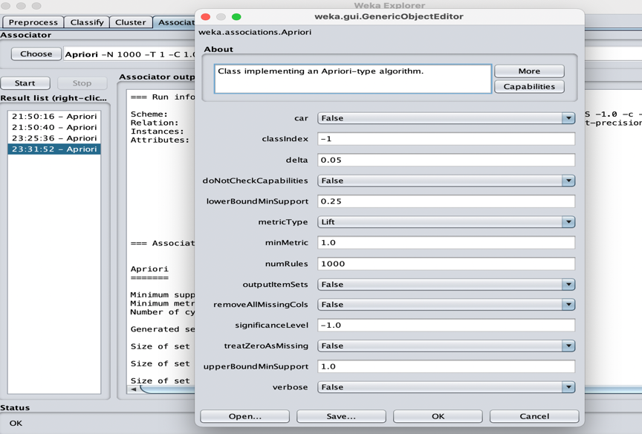

Picture 2.1.4

Then click the Start button to obtain the results below. Compare the rules discovered to rank the degrees.

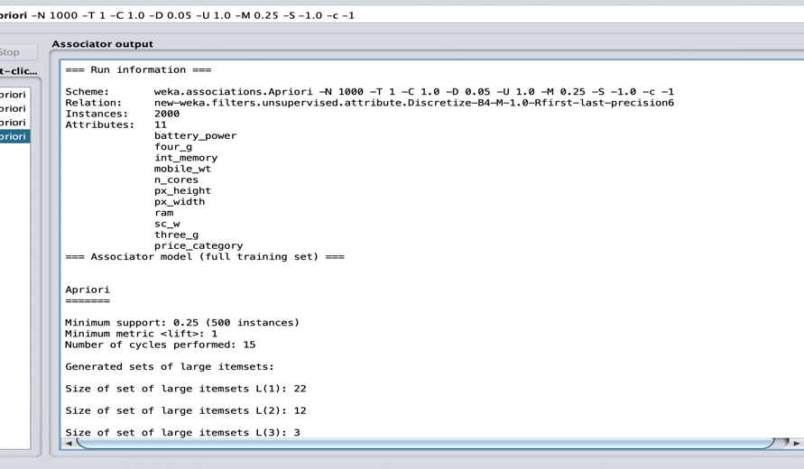

Picture 2.1.5

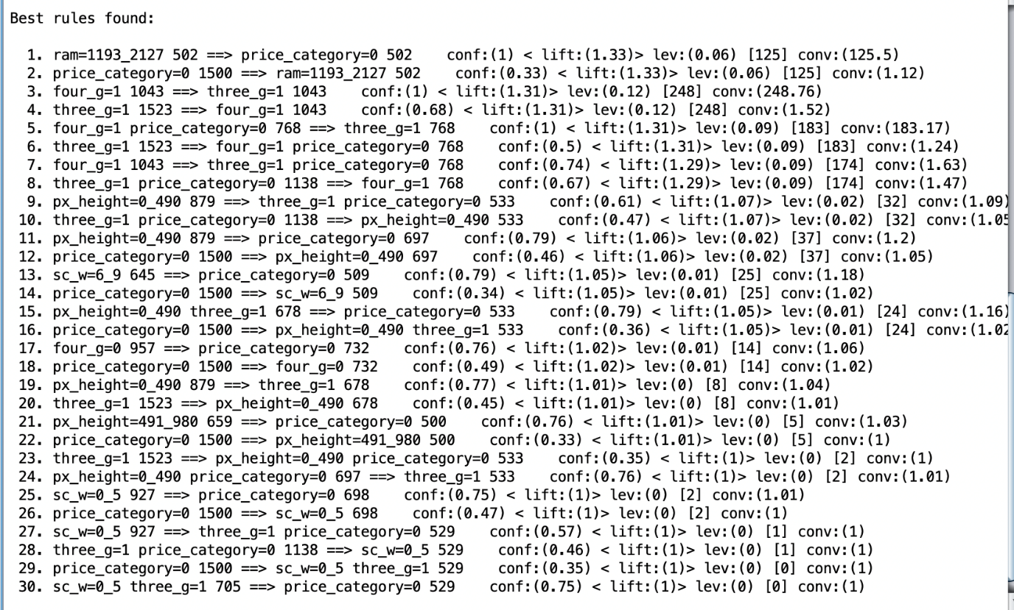

Picture 2.1.6

According to the results of confidence , I ranked the degrees with lift greater than 1.1：

1. ram=1193_2127 ==> price_category=0 conf:(1) < lift:(1.33)>

2. price_category=0 ==> ram=1193_2127 conf:(0.33) < lift:(1.33)>

3. four_g=1 ==> three_g=1 conf:(1) < lift:(1.31)>

4. three_g=1 ==> four_g=1 conf:(0.68) < lift:(1.31)>

5. four_g=1 price_category=0 ==> three_g=1 conf:(1) < lift:(1.31)>

6. three_g=1 1523 ==> four_g=1 price_category=0 768 conf:(0.5) < lift:(1.31)>

7. four_g=1 1043 ==> three_g=1 price_category=0 768 conf:(0.74) < lift:(1.29)>

8. three_g=1 price_category=0 1138 ==> four_g=1 768 conf:(0.67) < lift:(1.29)> l

**2.2 Explain the top k rules (according to confidence)**

From the screenshot: Generated sets of large itemsets: Size of set of large itemsets L(3): 16,I can see that the top k is 3 .And when lowerBoundMinSupport is 0.1 and minMetric is 0.1, there are totally 16 association rules with top k.

Rank them according to the confidence from high to low:

1. four_g=1 ram=1193_2127 three_g=1 ==> price_category=0 <conf:(1)>

Explaination: When a phone has four_g and three_g function and ram is between 1193 and 2127, we have 100% confidence that the phone price is low price.

**2.3 Explain the meaning of the k rules**

The most basic model is an item set, which refers to a collection of several items. For example, if a phone has three_g function, four_g function and blue color, the set {"three_g", "four_g", "blue"} is an item set. In the set {"three_g", "four_g", "blue"}, there are a total of three items, namely "three_g", "four_g" and "blue", so an item set containing k items is called a k item set (k-itemset).

In weka, k-itemsets are used to explore (k+1)-itemsets. First, find the set of frequent 1-itemsets. Recorded as L1, L1 is used to find the set L2 of frequent 2-itemsets, and then used to find L3, and so on, until no frequent k-itemsets can be found. You need to scan the database once to find each Lk.

**2.4 Conclusion and recommendation for a high priced mobile phone**

1. No 18. four_g=1 ram=3064_max ==> price_category=1 <conf:(0.86)>

When a phone has four_g fouction and the value of ram is over 3064, we have 86% confidence that the phone price is high price. Therefore, we can reckon that high mobile should be equipped with four_g function and ram greater than 3064.

**Conclusion**

To sum up, the rules show that attribute “ram” has significant effect on phone price, when the value of ram is over 3064, the phone is definitely high price.

At the same time, four_g, three_g function, and Screen Width smaller than 5cm will play positive correlations to the high price of mobile phones. Therefore, when mobile phone manufacturers are designing mobile phones, phones should be equipped with ram greater than 3064, three_g and four_g function and Screen Width smaller than 5cm so that phones have high price.

**Task3: Classification**

In this process, two classifiers (Decision tree and logistic regression) are trained based on all the features of the cellphones, which means attribute reduction is not conducted in this process.

**3.1 Decision tree:**

In this part, a decision tree is built with 10 folds cross-validation. The parameters are as bellow. The minNumObj is set to 15. The unpruned is set as true. Although a subdivided model may have higher accuracy in prediction, it is not useful to figure out which features will lead to high priced mobile phone. Therefore, the minNumObj is set to 15.

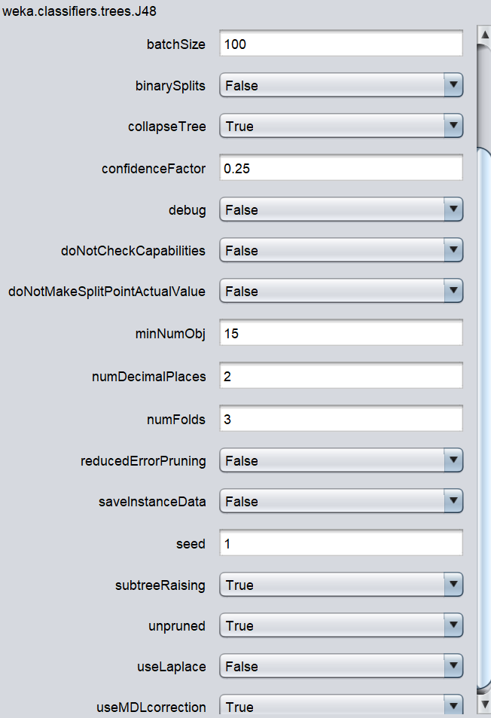

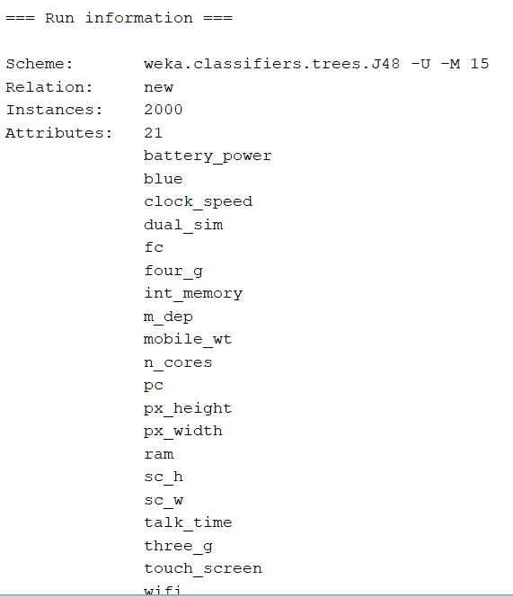

Picture 3.1.1

**Model evaluation**

Totally, the percentage of correctly classified instances are 94.8% and the percentage of incorrectly classified instances are 5.2%.

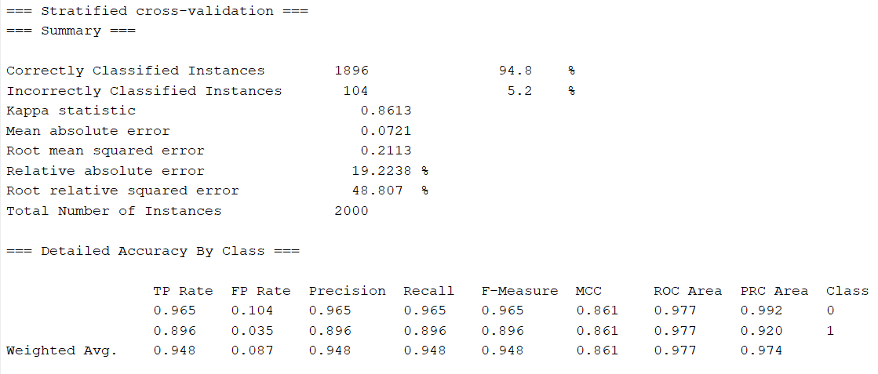

Picture 3.1.2

**Precision score:** The precision score for low priced mobile phones (Class 0) is 96.5%, which means the percentage of instances the model thinks that are low priced are actually labelled low priced. On the other hand, the precision score for high priced mobile phones (Class 1) is 89.6%, which is lower than the low priced mobile phone class. This score means the percentage of instances the model thinks that are high priced are actually labelled high priced.

**Recall score:** The recall score for low priced mobile phone is 96.5%, which suggests the percentage of low priced instances the model “recalled” out of all the low priced instances. On the other hand, the recall score for high priced mobile phones (Class 1) is 89.6%, which is lower than the low priced mobile phone class. This score means the percentage of high priced instances the model “recalled” out of all the high priced mobile phone instances.

**F Measure:** The F1 score for low priced mobile phone is 96.5% and for high priced mobile phone it is 89.6%.

**Confusion matrix:**

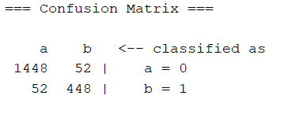

Picture 3.1.3

In the confusion matrix, the low priced mobile phone is class a, while the high priced mobile phone is class b. There are 1448 correctly classified low priced mobile phones and 448 correctly classified high priced mobile phones.

**Visualize tree:**

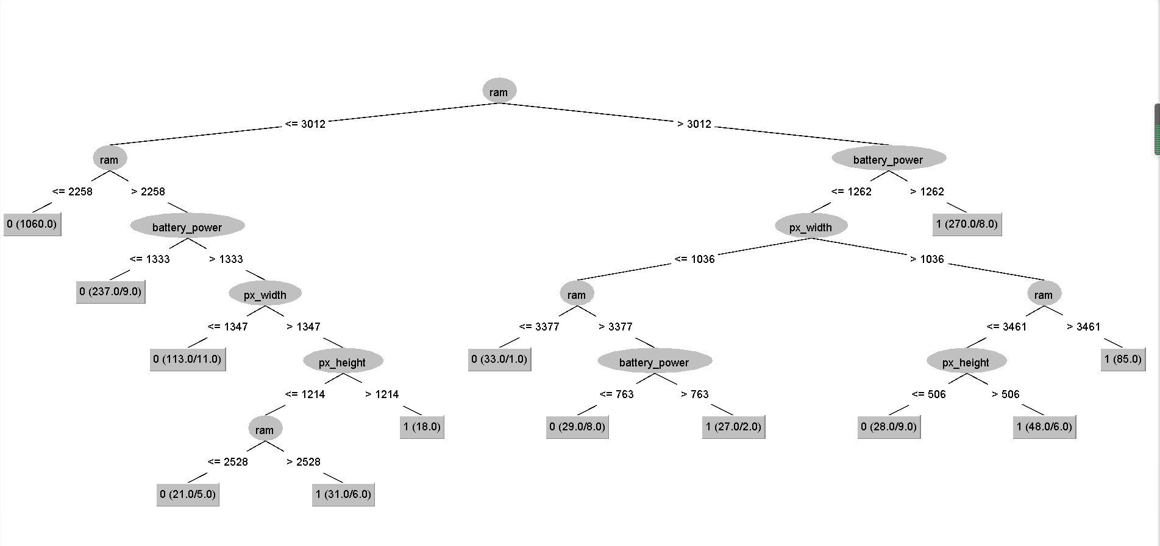

Picture 3.1.4

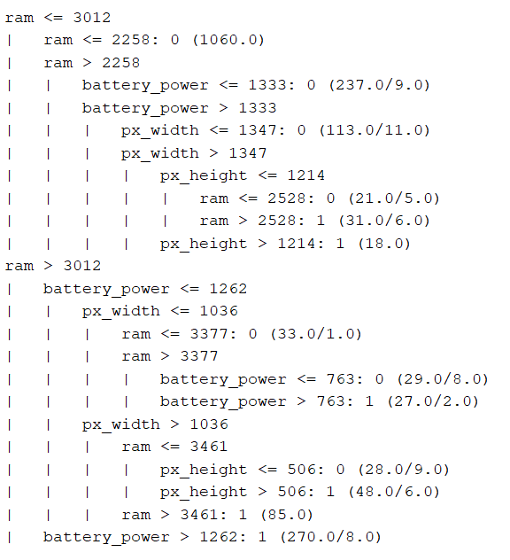

Picture 3.1.5

Based on the classification result, we can find several features have great influence on classification result. They are “Ram”,” Battery power”, “Px_height” and “Px_width”. When ram is less than 2258, there is no possibility that the phone is a high priced mobile phone. When ram is between 2259 to 3012, battery power and px_width and px_height can be other influencers. When mobile phones have higher score in those attributes, they are more likely to be predicted as high price mobile phones. When ram is bigger than 3012, those phones are more likely to be high priced mobile phones, but the other three attributes will still influence the classification result.

**3.2 Logistic regression**

The logistic regression model is built with 10 folds cross-validation. The parameters are as bellow.

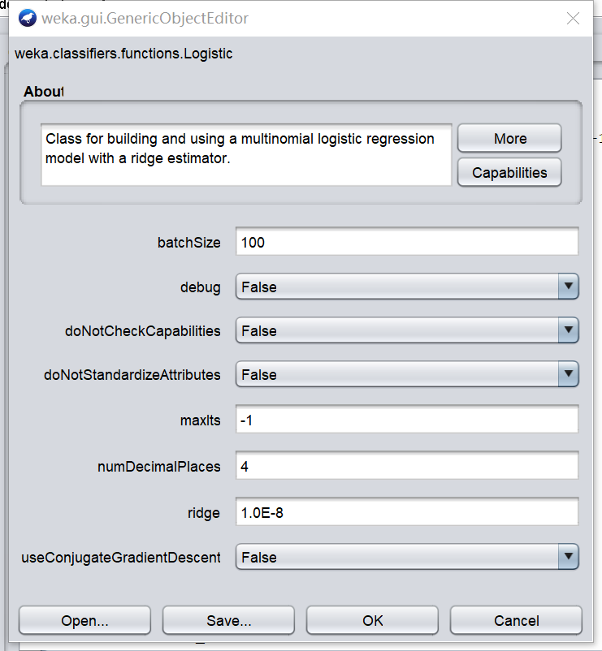

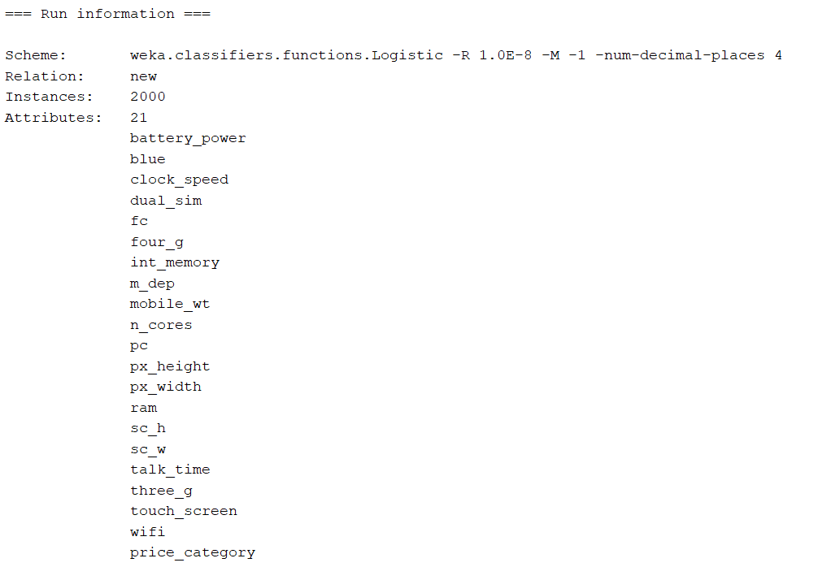

Picture 3.2.1

**Model evaluation**

The total accuracy of the model is 98.95%. The percentage of incorrectly classified instances is 1.05%.

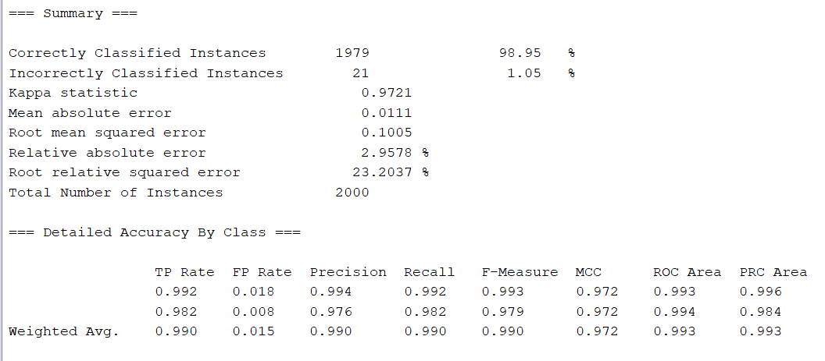

Picture 3.2.2

**Precision score:** The precision score for low priced mobile phones (Class 0) is 99.4%, which means the percentage of instances the model thinks that are low priced are actually labelled low priced. On the other hand, the precision score for high priced mobile phones (Class 1) is 97.6%, which is lower than the low priced mobile phone class. This score means the percentage of instances the model thinks that are high priced are actually labelled high priced.

**Recall score:** The recall score for low priced mobile phone is 99.2%, which suggests the percentage of low priced instances the model “recalled” out of all the low priced instances. On the other hand, the recall score for high priced mobile phones (Class 1) is 98.2%, which is lower than the low priced mobile phone class. This score means the percentage of high priced instances the model “recalled” out of all the high priced mobile phone instances.

**F Measure:** The F score for low priced mobile phone is 99.3% and for high priced mobile phone it is 97.9%.

**Confusion matrix:**

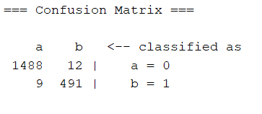

Picture 3.2.3

In the confusion matrix, the low priced mobile phone is class a, while the high priced mobile phone is class b. There are 1488 correctly classified low priced mobile phones and 491 correctly classified high priced mobile phones.

**Model meaning**

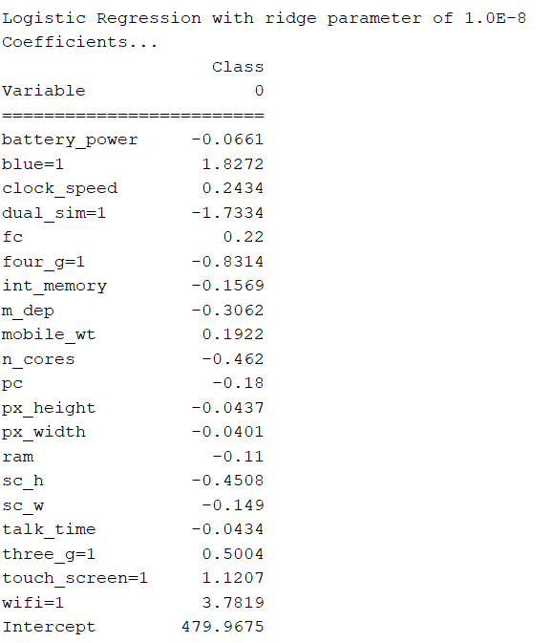

Picture 3.2.4

Inside the model, there are coefficient in front of each features. When the coefficient is negative, it means such feature will lead to high priced mobile phone. When the coefficient is positive, it means such feature will lead to low priced mobile phone. The features related to high priced mobile phone are as follow:

|  |
| --- |
| **Features** |
| battery_power |
| dual_sim=1 |
| four_g=1 |
| int_memory |
| m_dep |
| n_cores |
| pc |
| px_height |
| px_width |
| ram |
| sc_h |
| sc_w |
| talk_time |

Table 3.2.1

**Conclusion**

Based on the two classification results, we can judge that there are four great influencers among all the attributes which are “Ram”,” Battery power”, “Px_height” and “Px_width”. Other attributes like four_g and n_cores also have fewer influences to the prediction result.

**Task 4: Clustering**

**4.1 Run a clustering algorithm**

According to the result of Task 1, I keep relevant features and delete irrelevant attributes.

1. I try to calculate accuracy of different data in Weka.

For original data:

Numeric type: transfer data from first to No.20 (Because Class must be nominal for class based evaluation, keeping nominal type for price_category) to numeric data by filters->unsupervised->attribute->OrginalToNUmeric and apply the filter OrginalToNUmeric to first 20 attributes.

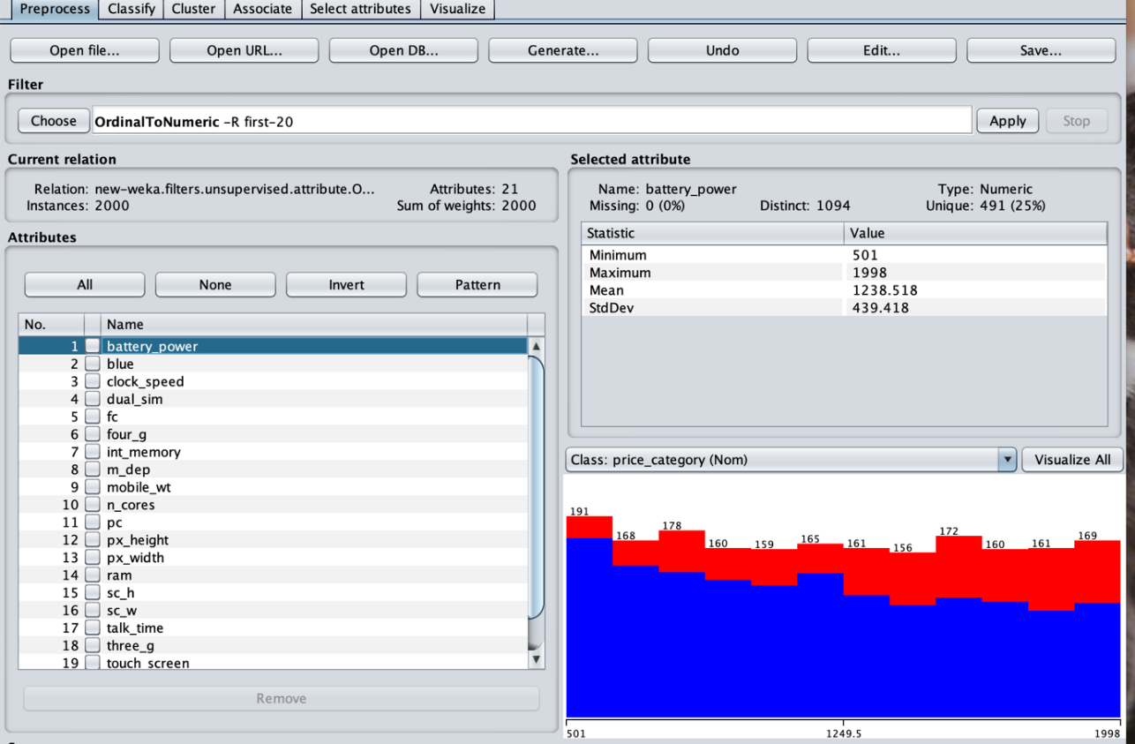

Picture 4.1.1

Second, Select the Cluster tab, and Choose SimpleKMeans and change number of clusters to 2, and select Classes to clusters evaluation as Cluster mode, using the last column price_category, which represent the high or low phone price. From picture, “Incorrectly clustered instances” is 49.5%.

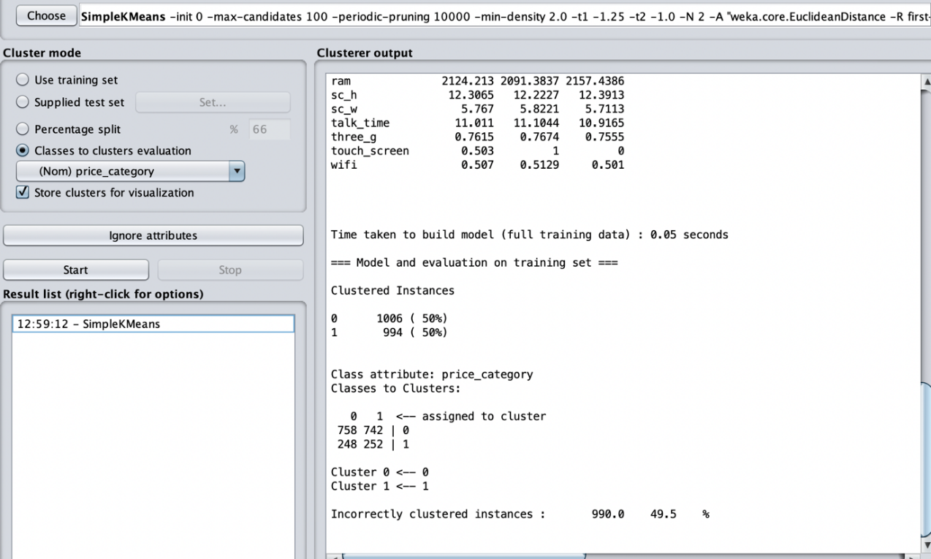

Picture 4.1.2

Nominal type: transfer all to nominal data by filters->unsupervised->attribute->NumericToNominal and apply the filter NumericToNominal to all attributes.

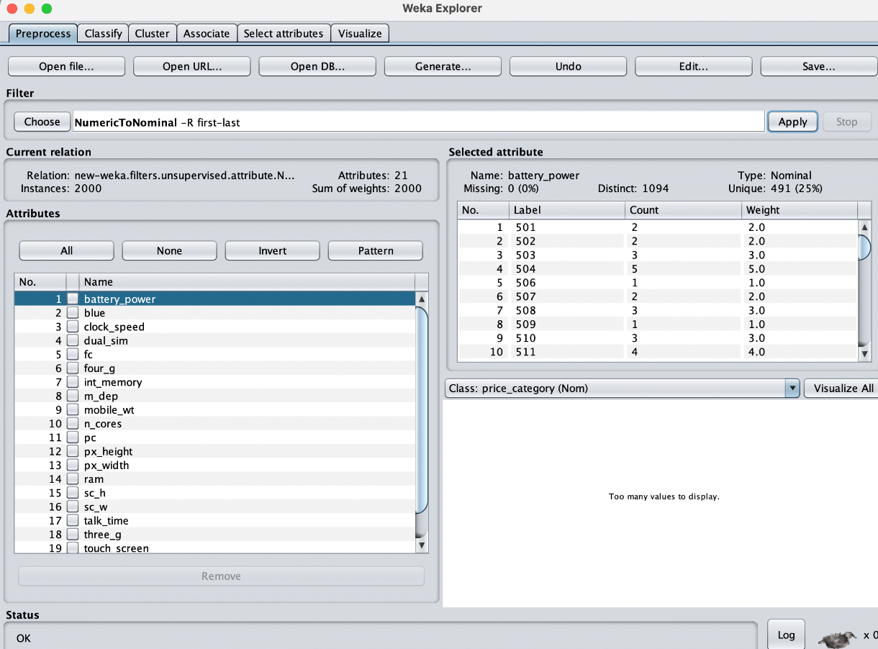

Picture 4.1.3

Then getting 44% incorrectly clustered instances:

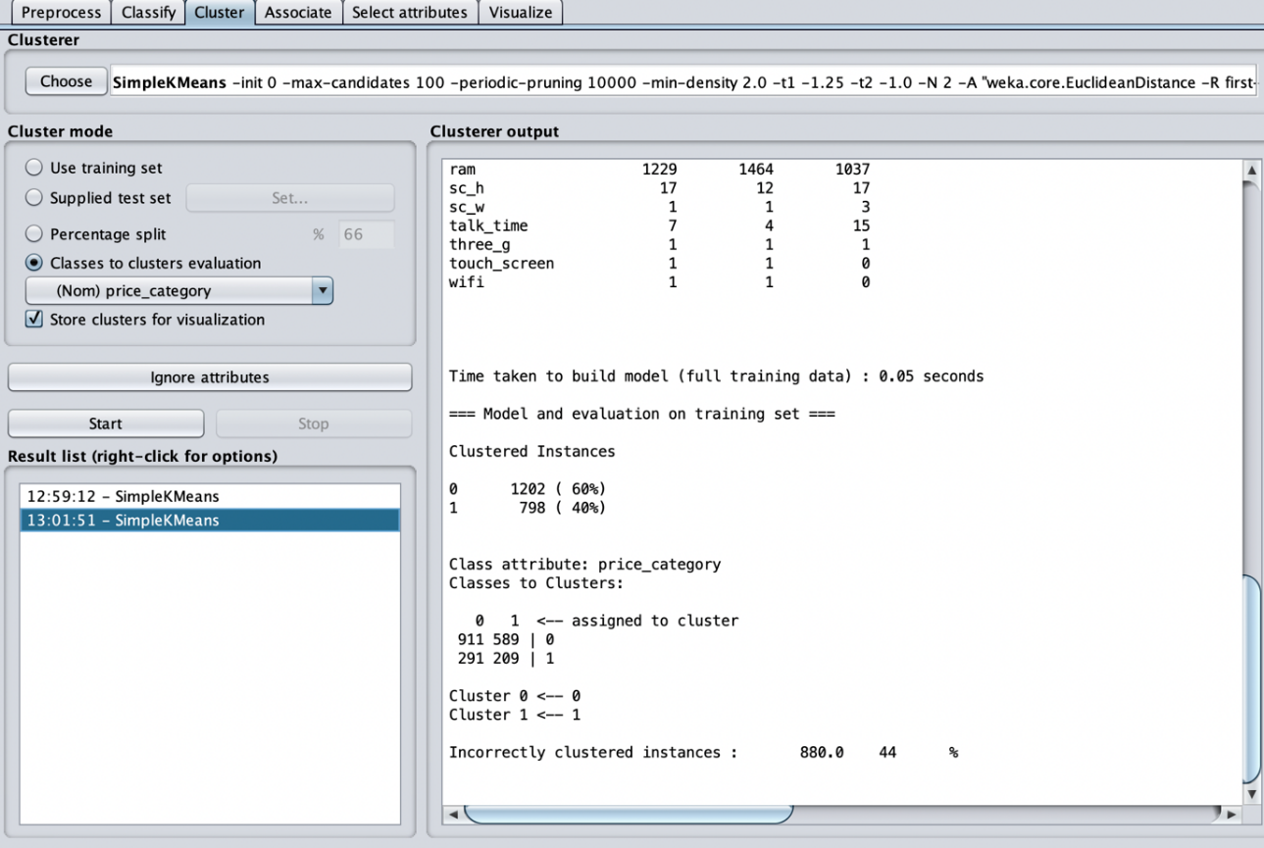

Picture 4.1.4

For selected and discretized data according to Task 1:

Nominal type: transfer all to nominal data by filters->unsupervised->attribute->NumericToNominal and apply the filter NumericToNominal to all attributes.

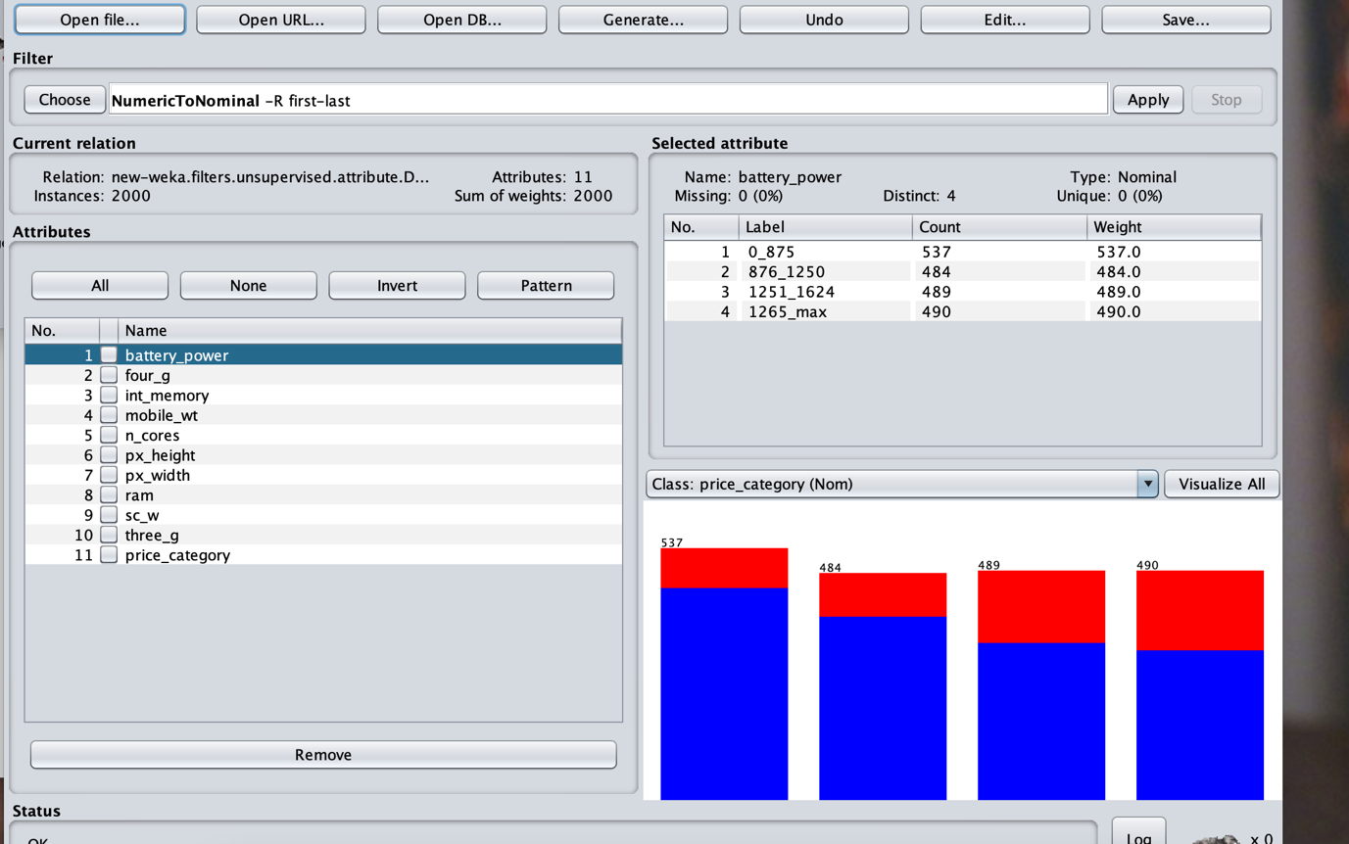

Picture 4.1.5

Second, select the Cluster tab, and choose SimpleKMeans. Change number of clusters to 2 and select Classes to clusters evaluation as Cluster mode. Using the last column price_category, which represent the high or low phone price. From picture, “Incorrectly clustered instances” (40.75%) is less than 49%.

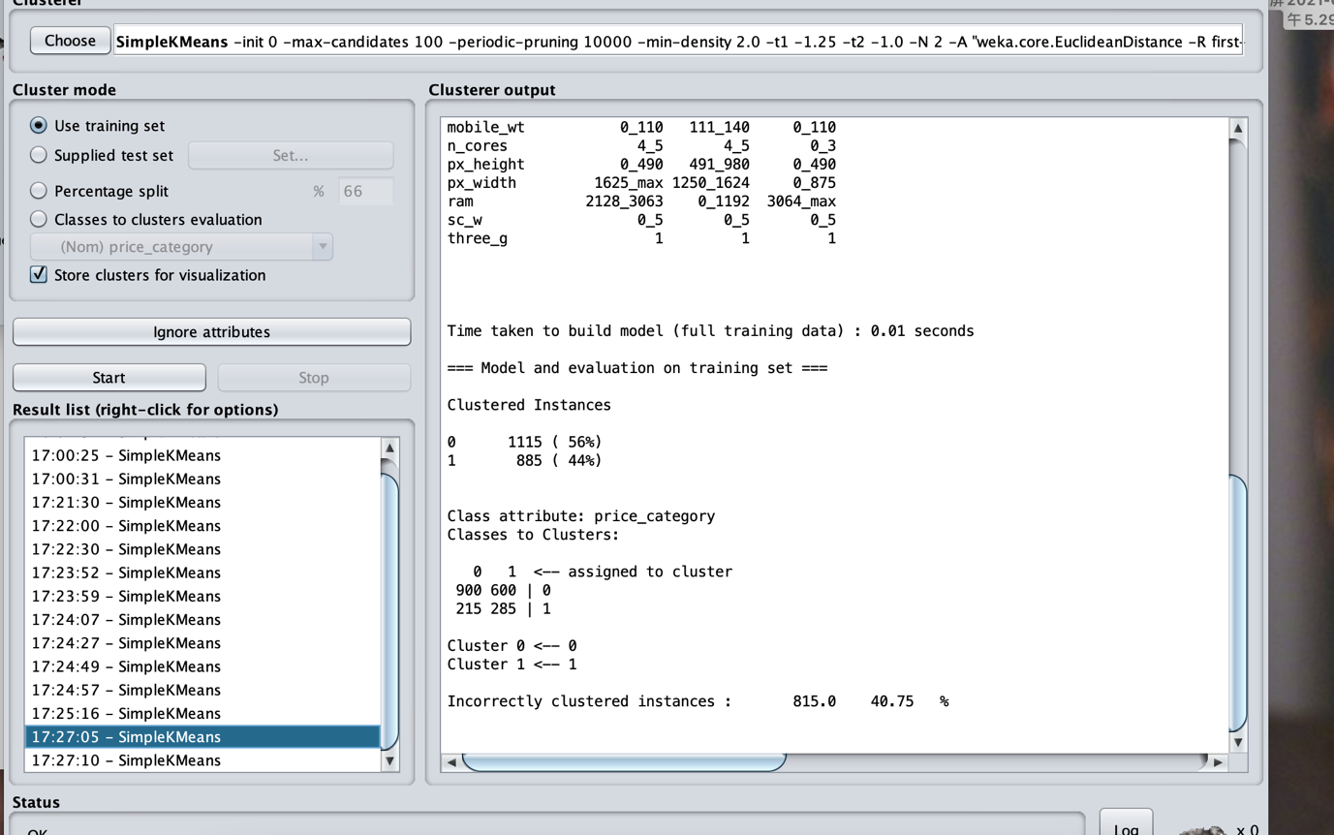

Picture 4.1.6

Numeric data:Applying the NorminalToBinary filter to all the attributes;

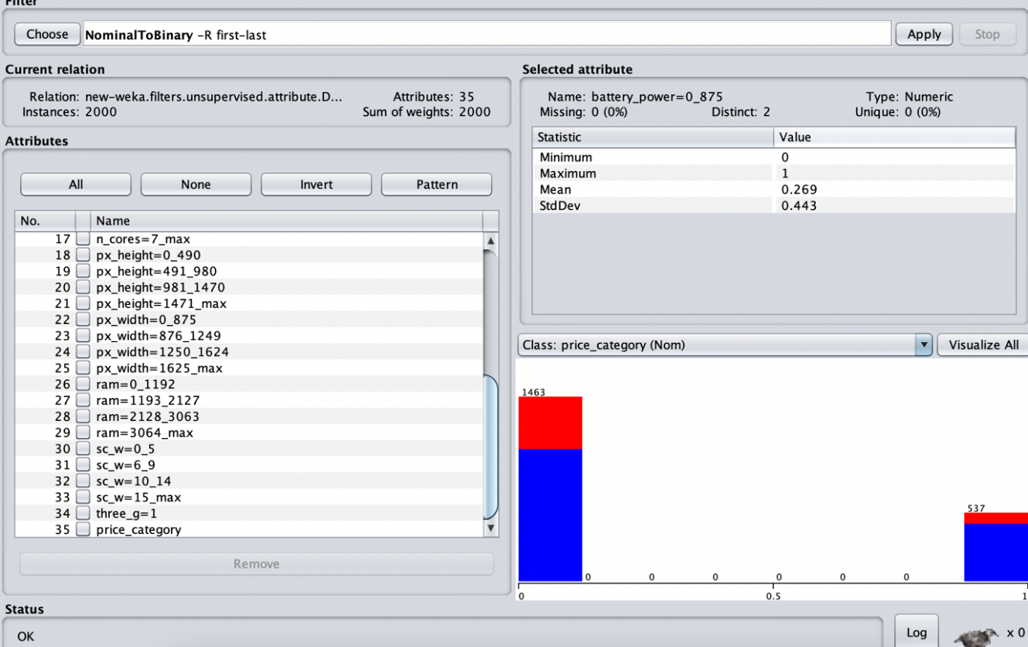

Picture 4.1.7

Then, doing the same step as “For nominal data”. In picture, “Incorrectly clustered instances” is equal to 49.25%, which is more than those of “For nominal data”. Therefore, we use nominal data to cluster.

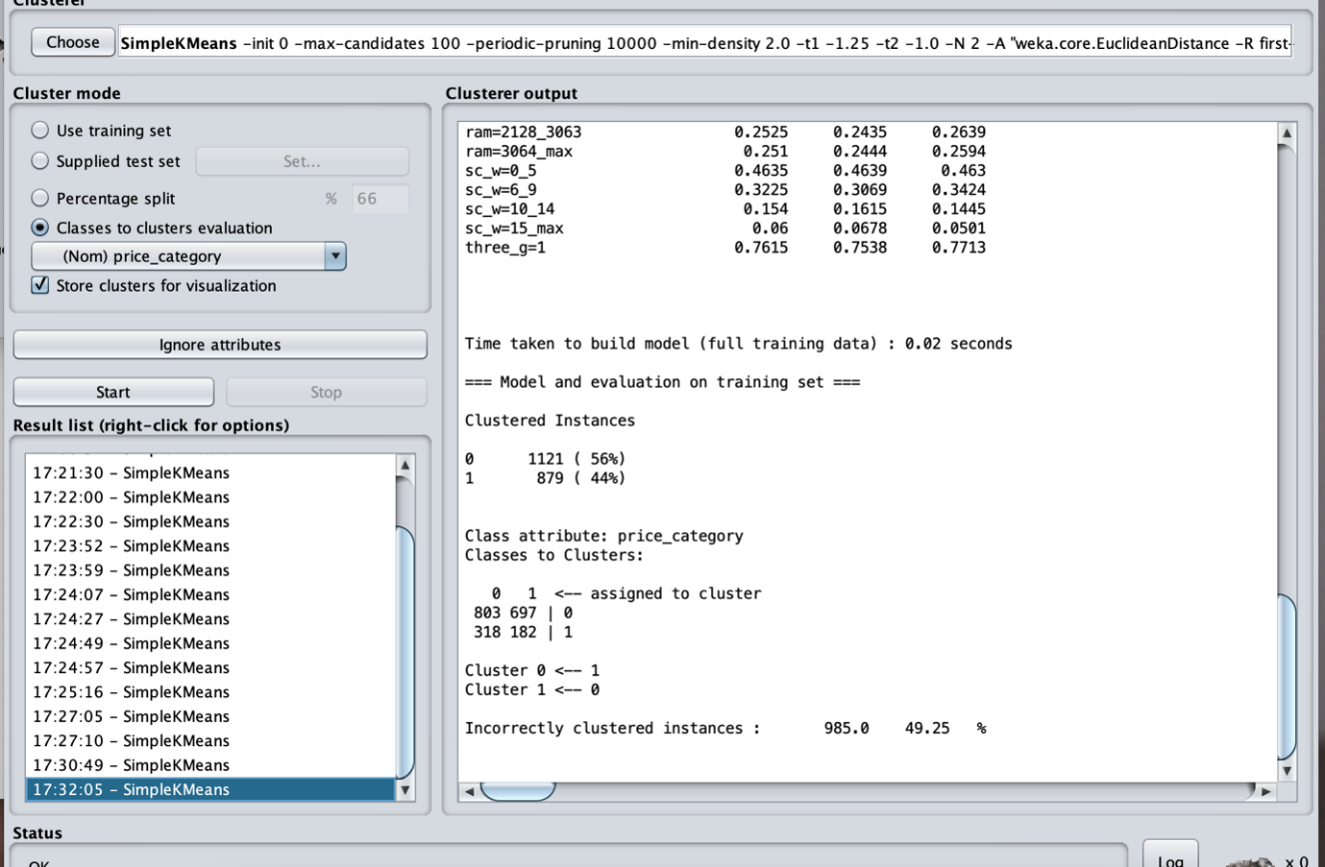

Picture 4.1.8

Therefore, nominal data selected and discretized in Task 1 is better for evaluating cluster.

**4.2 Interpretation with respect to the target variable**

(1) For classes to clusters evaluation,

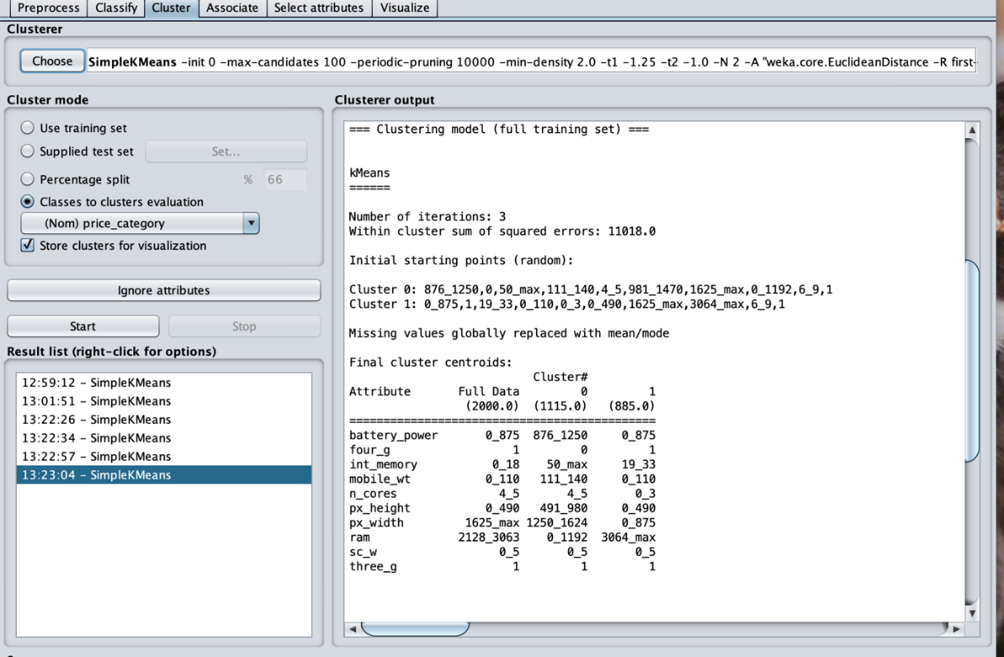

Picture 4.2.1

From Picture 4.2.1, the conclusion is that when price_category = 1, the mobile phone has the following features: battery_power under 875, int_momory (between19 and 33), weight under 110g, number of cores of processor under 3, Pixel Resolution weight under 875 g, ram over 3064, Pixel Resolution height under 490 g, and four_g function. At the same time, both high-priced and low-priced mobile phones have three_g function. Therefore, three_g feature has no obvious correlation with the price of mobile phones.

I check the results by right click on the model in the result-list and select Visualise cluster assignments, choosing “Cluster” as the x axis, “Instance number” as the y axis, and each attribute as the colour:

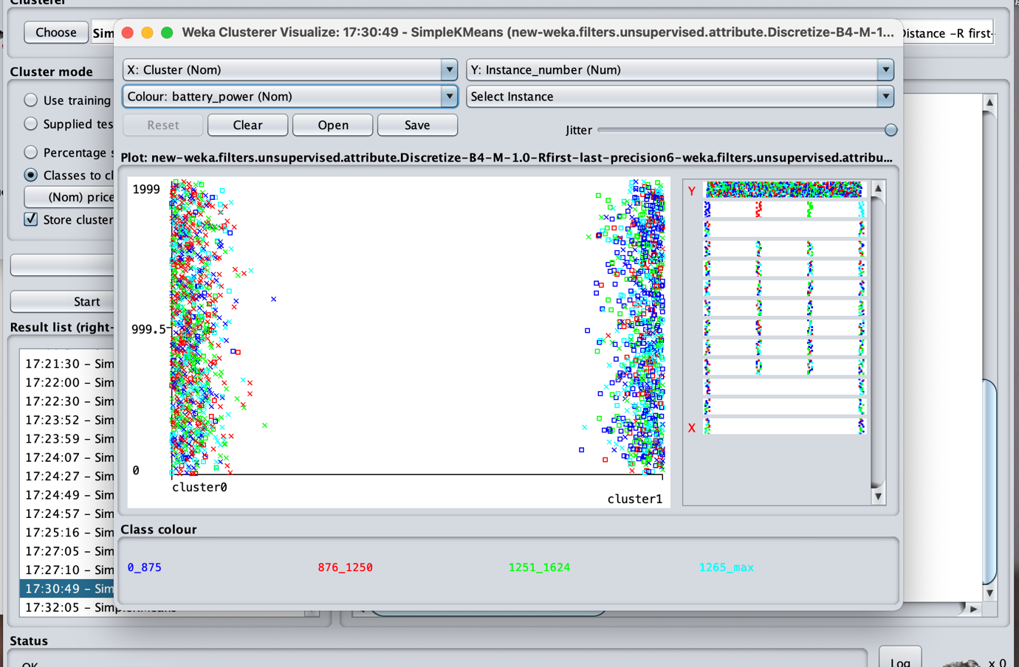

Picture 4.2.2 battery_power as the colour

Picture 4.2.2 shows that when price_category is equal to 1,there are more phone whose battery_power is under 875.

**Conclusion**

In conclusion，in order to make sure a mobile phone can be sold at a high price. The manufactures should build a mobile phone which contains the following features. The ram should be over 3064. The battery_power should be set under 875. The int_memory should be set between 19 and 33. The weight should be controlled under 110g. The number of cores of processor should be set under 3, Pixel Resolution weight should be controlled under 875g. The phone also should have four_g function.

**Task5: Data reduction**

In this part numerosity reduction and attribute reduction is conducted. Numerosity reduction is conducted by splitting data set into two subsets and make use of the one with 80% of the original data set. In attribute reduction, both **GainRatioAttributeEval** and **PCA** is conducted to select attributes. After data reduction, the remain data set is reused in classification. The comparison with the original classifier is conducted in this part.

1. **Numerosity reduction**

In this part, the data set is split into two parts in python. The subset with 80% of the original data set(mp_df80) is used in the GainRatioAttributeEval step.

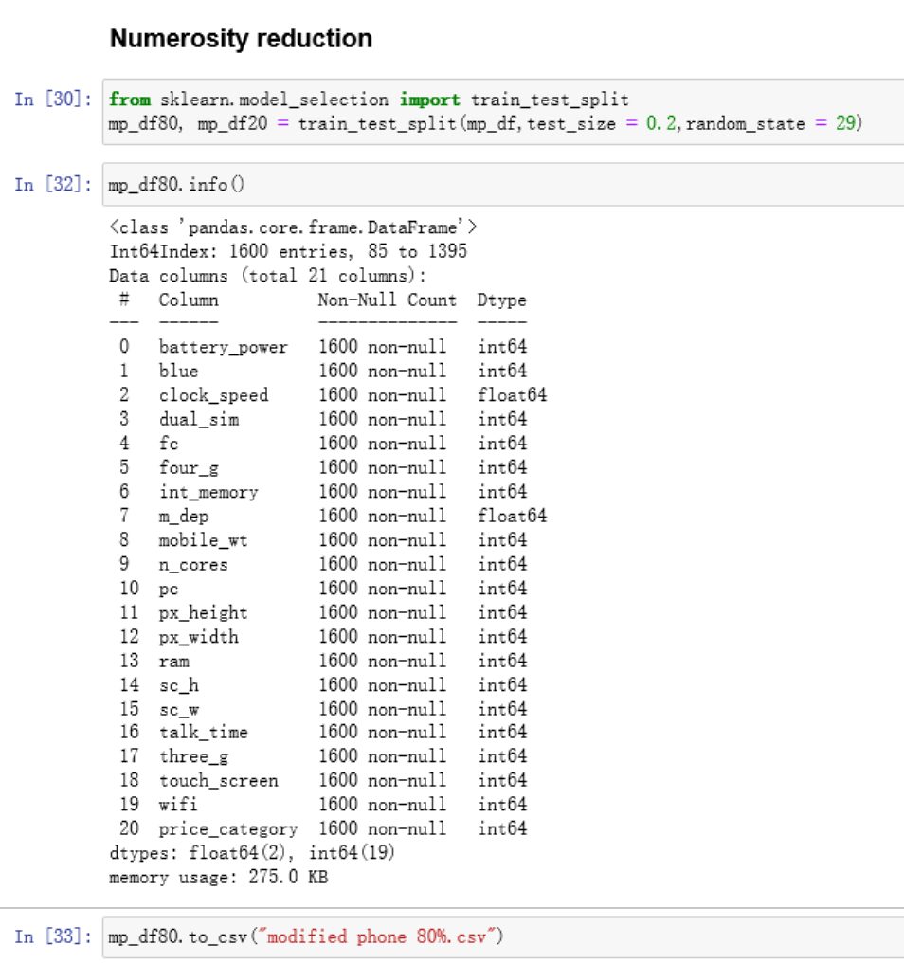

Picture 5.1.1

Use GainRatioAttributeEval to rank attributes

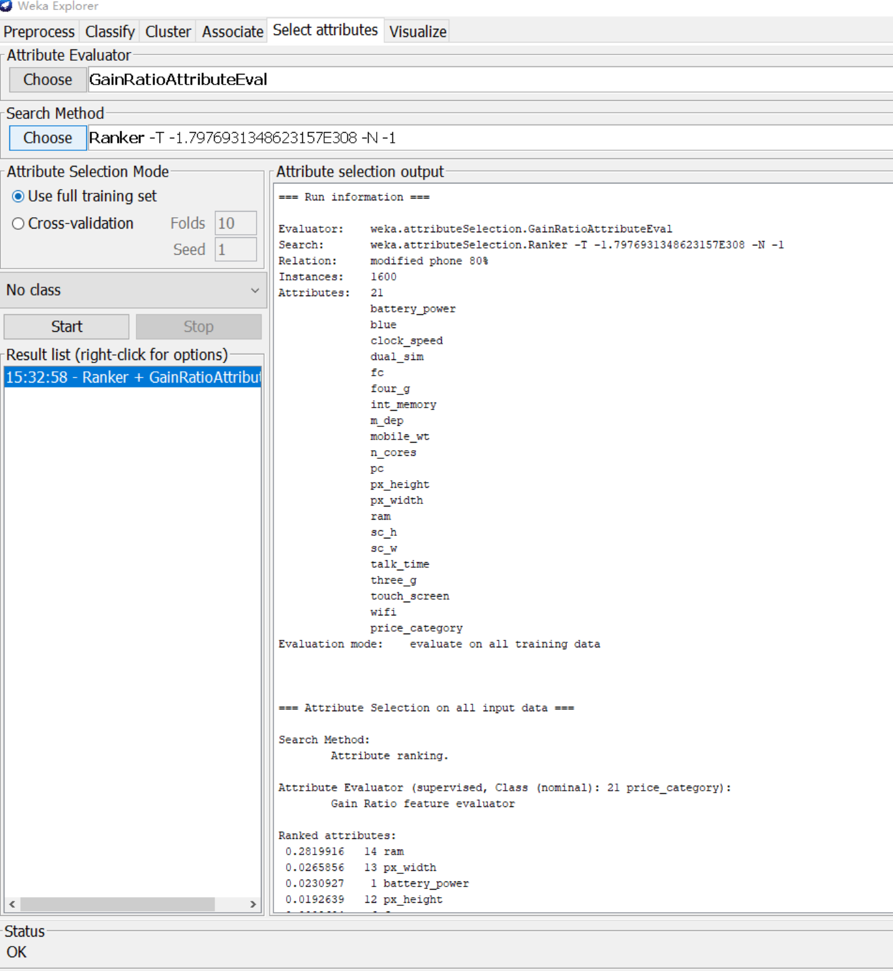

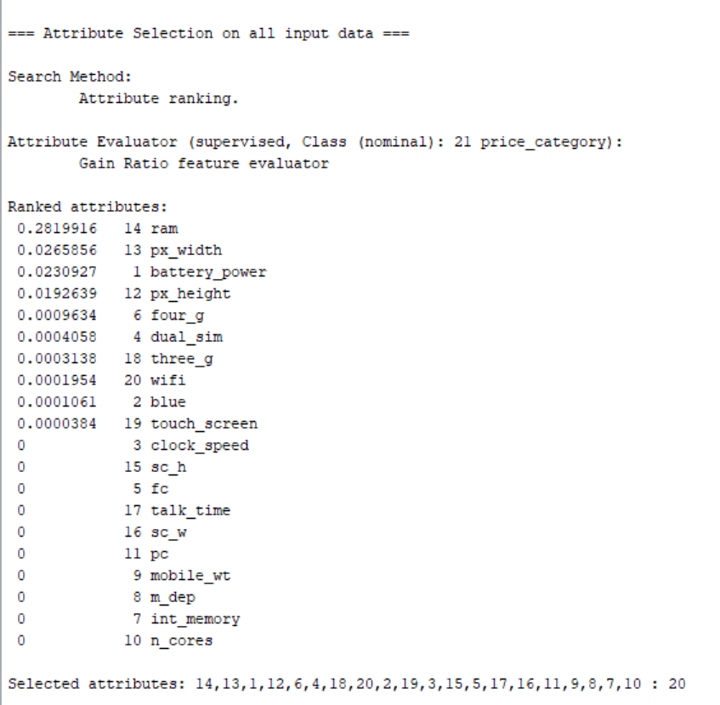

Picture 5.1.2

Based on the result, in all the 20 attributes there are 10 attributes that has significant influence to the model prediction. But I will only select those with coefficient bigger than 0.01. The remain attributes are ram, battery_power, px_width and px_hight.

After attribute reduction, the data set looks like this:

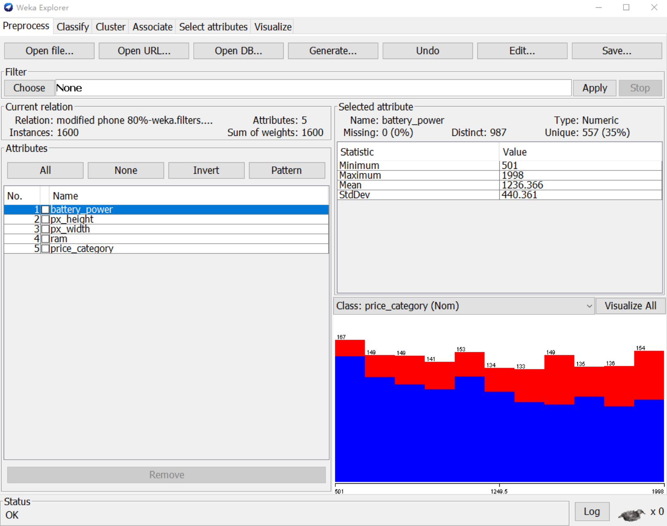

Picture 5.1.3

**Classification on reduced data set**

Decision tree (on reduced data set)

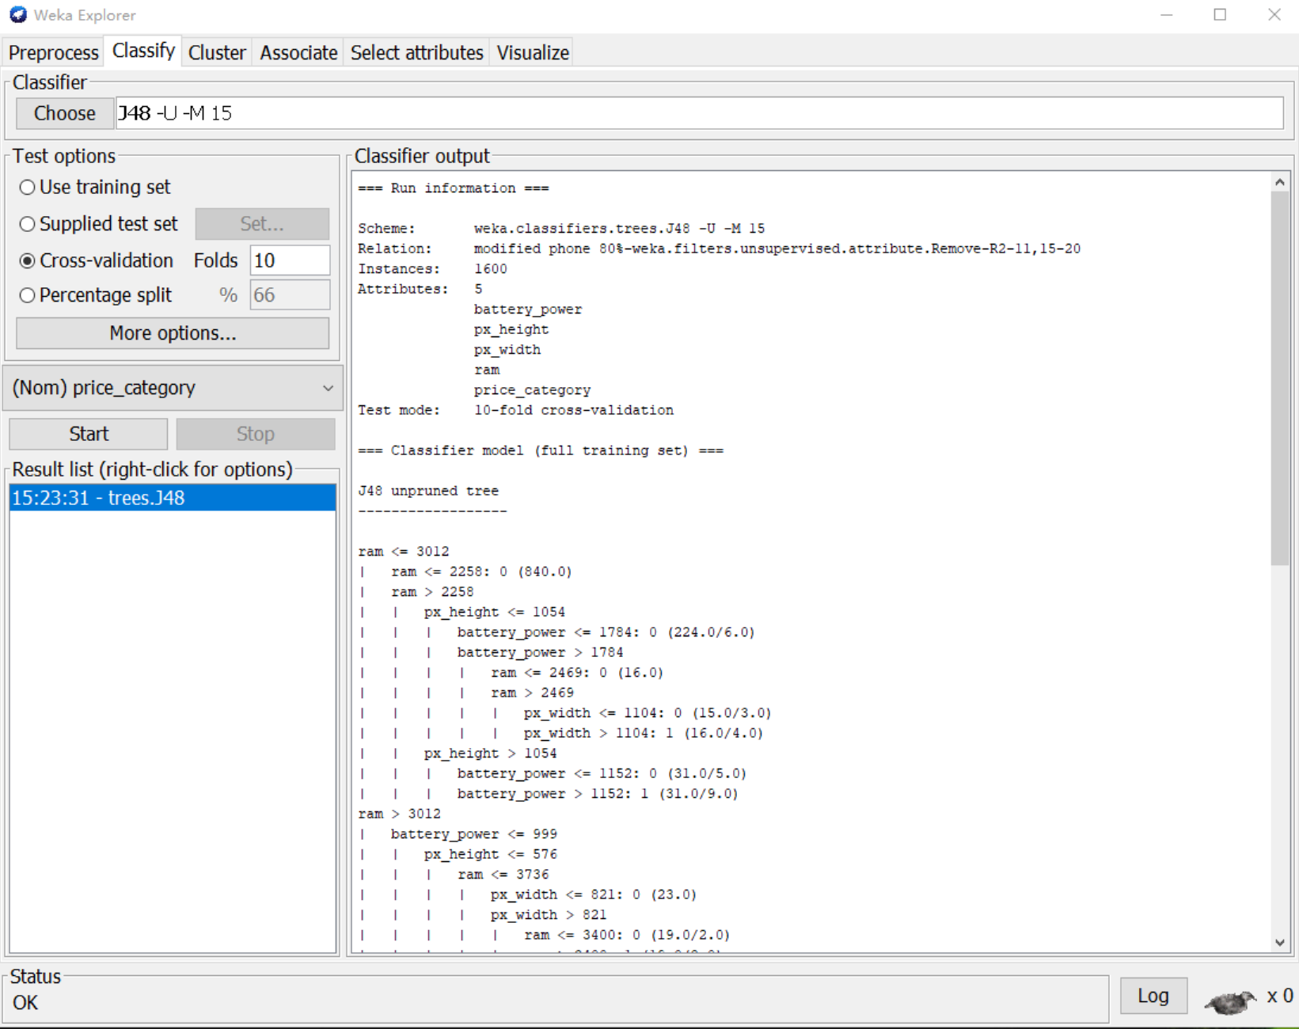

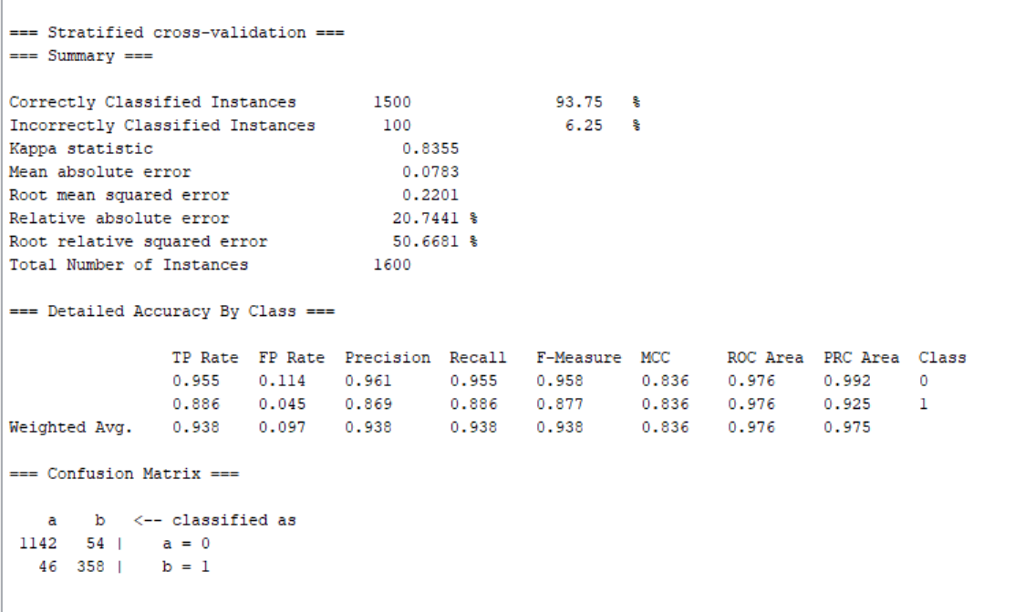 Picture 5.1.2

**Comparison and conclusion**

|  |  |  |
| --- | --- | --- |
| **Decision tree** | **Original data set** | **Reduced data set** |
| Accuracy | 94.8% | 93.75% |
| Precision | 94.8% | 93.8% |
| Recall | 94.8% | 93.8% |
| F-measure | 94.8% | 93.8% |

Table 5.1.1

The result suggests decision tree classifier does not work well on the remain data set. The total accuracy drops to 93.75% followed by precision, recall and F-measure. The total change in accuracy is less than 5%. We can judge that the classifier performance is not improved after data reduction but the classifier is not influenced greatly with reduced data set.

Logistic regression (on reduced data set)

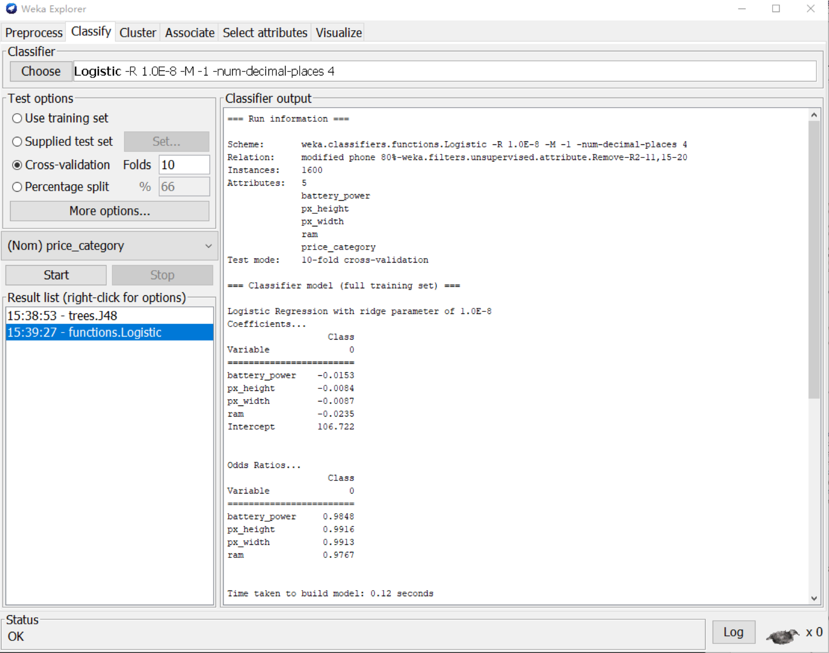

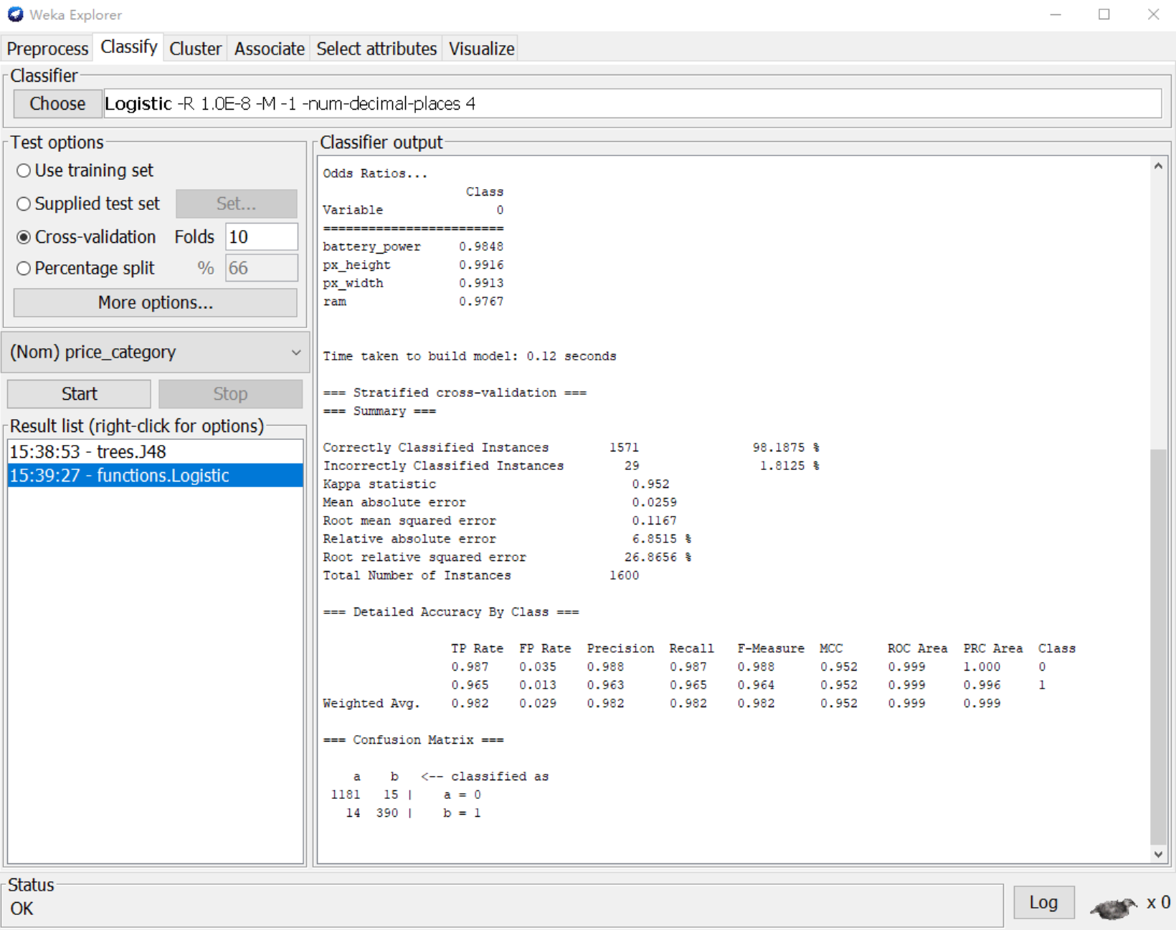

Picture 5.1.3

**Comparison and conclusion**

|  |  |  |
| --- | --- | --- |
| **Logistic regression** | **Original data set** | **Reduced data set** |
| Accuracy | 98.95% | 98.19% |
| Precision | 99% | 98.2% |
| Recall | 99% | 98.2% |
| F-measure | 99% | 98.2% |

Table 5.1.2

The total accuracy dropped about 0.8% after using reduced data set on logistic regression. Also, the precision, recall and F-measure dropped about 0.8%. So, we can conclude that data reduction does not improve the classifier but it has little influence on the classifier.

1. **Principal component analysis (PCA)**

In this part, Principal component analysis is conducted to the 80% of the original data set. The attributes are reshaped by Weka. The data has been processed for dimensionality reduction, only principal components are remained

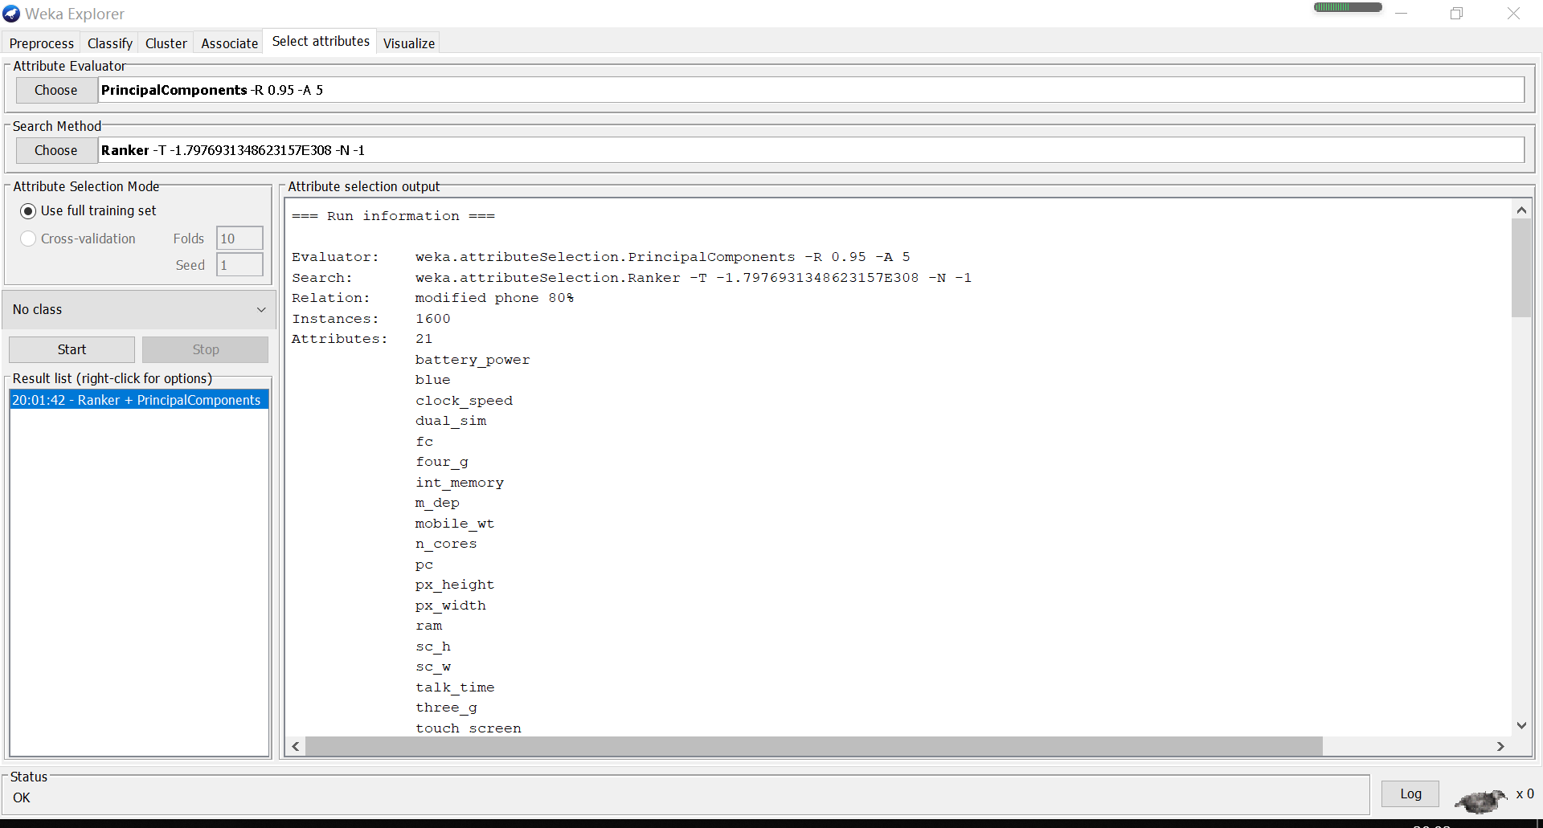

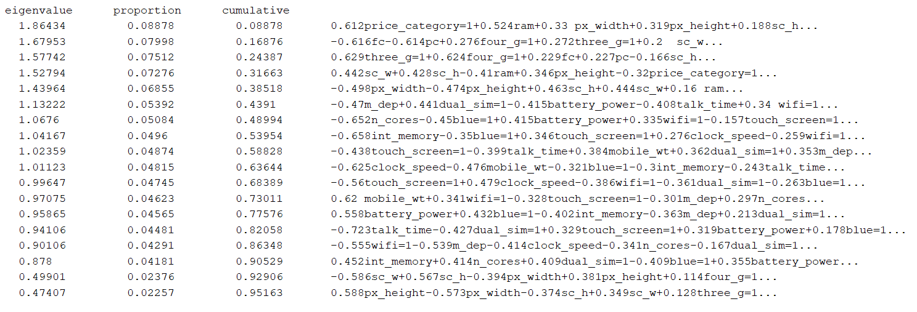

Picture 5.2.1

Based on all 20 attributes, the evaluator created 18 attributes ranked as follow:

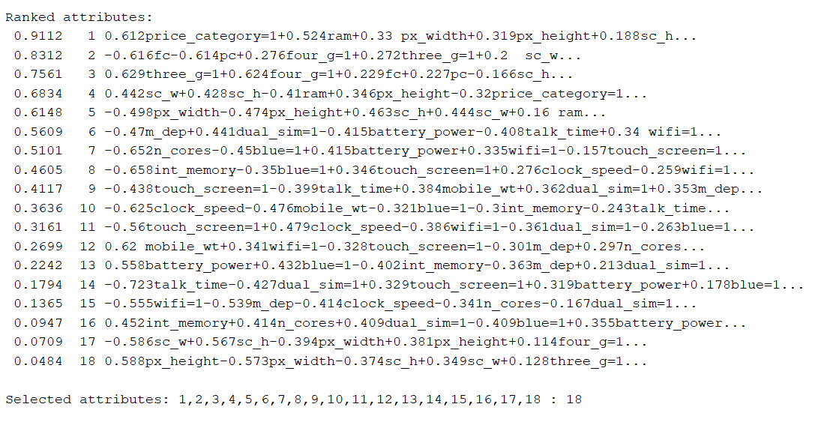

Picture 5.2.2

After selecting attributes, we use preprocess to reshape the original data.

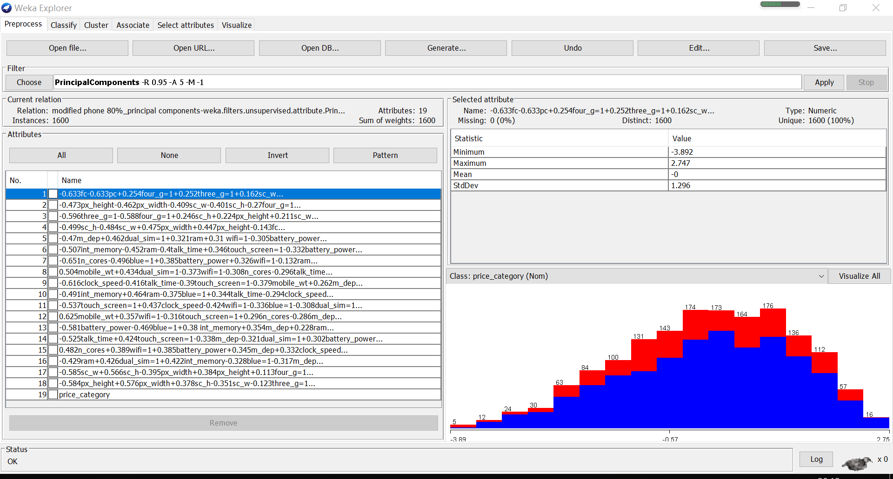

Picture 5.2.3

The new data set contain the following attributes.

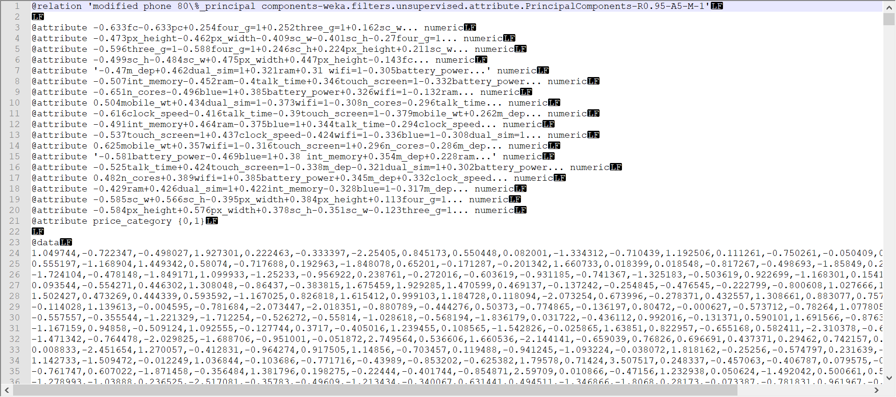

Picture 5.2.4

After conducting PCA on the 80% of the original data set, classification is reconducted.

**Classification after PCA**

Decision tress (reduced data set)

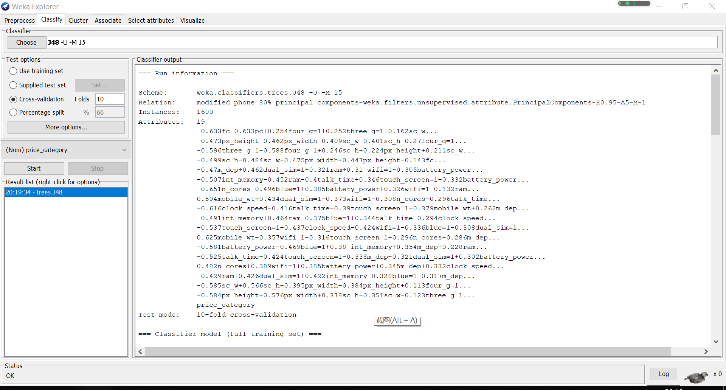

Picture 5.2.5

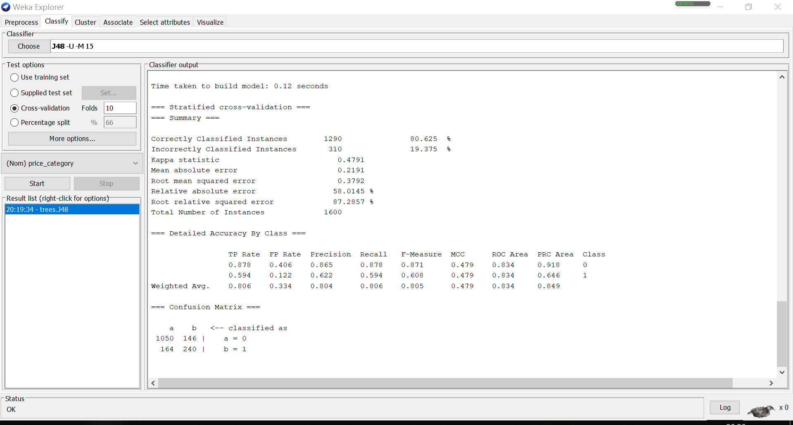

Picture 5.2.6

**Comparison and conclusion**

|  |  |  |
| --- | --- | --- |
| **Decision tree** | **Original data set** | **Reduced data set** |
| Accuracy | 94.8% | 80.625% |
| Precision | 94.8% | 80.4% |
| Recall | 94.8% | 80.6% |
| F-measure | 94.8% | 80.5% |

Table 5.2.1

The total accuracy drops from 94.8% to 80.6%. The precision, recall and F-measure also drop from 94% to 80%. The decision tree classifier does not work well on the reduced data set after PCA. In conclusion, decision tree does not work well with the reduced data set after PCA. The total accuracy drops about 10%, which means data reduction with PCA does not improve decision tree classifier.

Logistic regression (reduced data set)

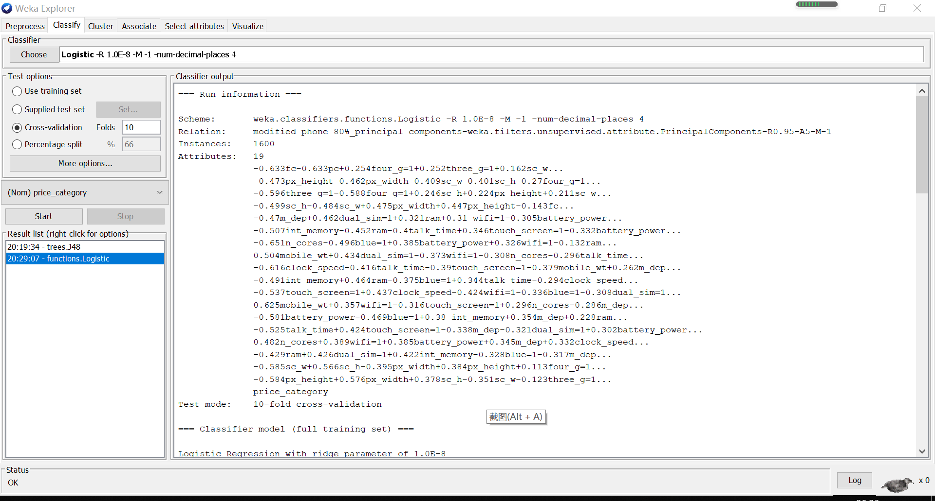

Picture 5.2.7

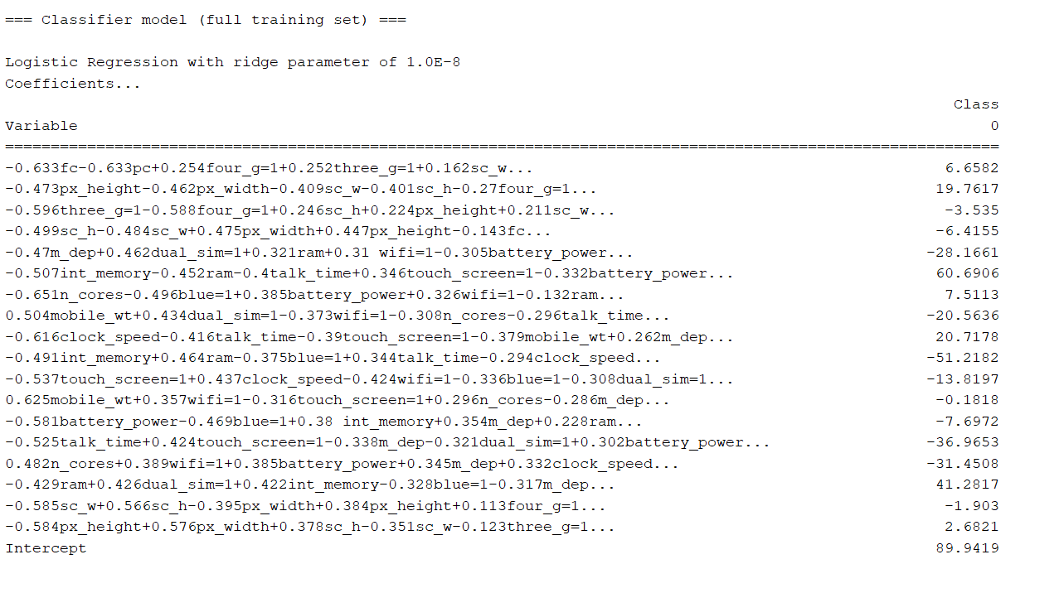

Picture 5.2.8

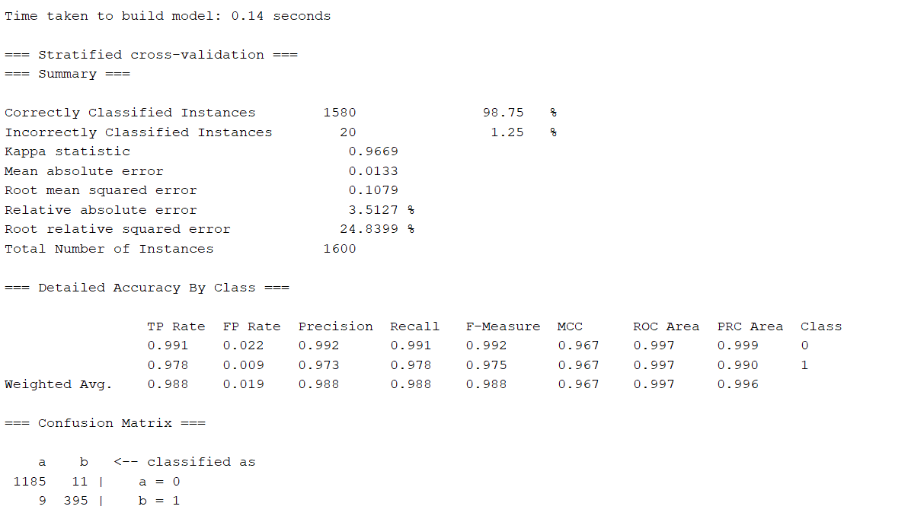

Picture 5.2.9

**Comparison and conclusion**

|  |  |  |
| --- | --- | --- |
| **Logistic regression** | **Original data set** | **Reduced data set** |
| Accuracy | 98.95% | 98.75% |
| Precision | 99% | 98.8% |
| Recall | 99% | 98.8% |
| F-measure | 99% | 98.8% |

Table 5.2.2

Through the comparison, we can find the total accuracy drops about 0.2%. Precision, Recall and F-measure also drop about 0.2%. Basically, there is no change in the prediction result. Therefore, we can conclude that the logistic regression classifier has the same performance on reduced data set. We may not say, data reduction can improve the classifier performance.

**Comparison between GainRatioAttributeEval and PCA**



Table 5.2.3

Through the table, we can find the performance of decision tree classifier are quite different after performing different ways of data reduction. The accuracy will drop less or more with reduced data set. However, for logistic regression, data reduction has little influence on the model prediction. The classifier performance is not improved with data reduction.

In conclusion, whether data reduction is influential to the classifier depends on how the data reduction is conducted. At the same time, different classifier will react differently on the reduced data set. But classifier performance will not be improved after data reduction.

**Task6: Comparison of association rule mining, classification and clustering**

After conducting three different ways to find the relationship between mobile phone features and mobile phone prices, some features are found have high relationship with high price, such as feature “ram”. However, some features that are contrary to people’s perception are also believed to have relationship with high price. For example, in clustering, we find battery power under 875 is related to high price. This finding is obviously contrary to our guess. In this part, we will compare our finding on the three different data mining ways, finding the similarity and difference of the outcome and make further discussion.

**In association rule mining**, we use the relevant variables selected in Task 1, ranked the degree with support, confidence and lift, and explained the top k rule, the meaning of the k rules in plain English, to get the characteristics of high-priced mobile phones.Confidence is used to measure the reliability of association rules. The higher the confidence, the more reliable the reasoning. When Lift=1, L and R are independent. The larger the number, the more it shows that L and R exist in the same mobile phone.

According to the rules, ram has significant effect on phone price, when the value of ram is over 3064, the phone is definitely high price. At the same time, a mobile phone with four_g and three_g function, and Screen Width smaller than 5cm will play positive correlations to the high price of mobile phones.

**In classification,** we use two different classifiers to make prediction on the full data set. After that, we conduct data reduction and make classification on the reduced data set. The classifiers are decision tree and logistic regression. Both of the classification processes are supervised learning. Therefore, all the classification accuracy are above 90%. After PCA, the performance of decision tree classifier very bad. This problem may be due to the way decision tree works. The logistic regression classifier is actually doing regression to produce binary prediction, so data reduction may not influence the outcome a lot.

By visualizing the decision tree and checking coefficients of independent variables in the equation of logistic regression, we find some features of a mobile phone are relevant to high price. Firstly, there are four significant features: ”Ram”, “Battery_power”, “Px_height” and “Px_width”. For feature Ram, the bigger, the better. When a phone has ram is bigger than 3012, it is very likely that the phone is a high priced mobile phone. When ram is 3461, it is sure that the phone will be sold at a high price.

For feature “Battery_power”, when it is bigger than 1262, the phone is sure to be a high priced mobiel phone. When it is less than 763, the phone is sure to be low priced. For “Px_height” and “Px_width”, those two features are not as significant as the previous two. We can conclude that a phone with higher “Px_height” and “Px_width” will be more likely to be sold at high price. The Px_height should be set more than 1214 and Px_width should be set more than 1036.

There are also some attributes that do not have so much significance, but they also should be included when building a mobile phone. The cell phone should have more memory, cores. It should have longer talk time and higher pc. The phone should have 4g and duam sim support.

**In clustering,** k-means is used in the analysis. This function is unsupervised learning which divides research objects into relatively homogeneous clusters. First, we compare different kinds of data sets to determine that the kind of data set generates the largest accuracy and the least incorrect instances. After comparison, we determine the data set with the least incorrect instances. Because of the data set, the accuracy of the best data set we found is only about 60%.

According to the results of our cluster analysis, if mobile phone manufacturers want to sell their phones at high prices, they will need to have some features: battery_power under 875, int_momory ( between19 and 33), weight under 110g, number of cores of processor under 3, Pixel Resolution weight under 875 g, ram over 3064, and four_g function.

Comparing the three different result, we can find the following outcome that are significant:

|  |  |  |
| --- | --- | --- |
| Association rule mining | Classification | Clustering |
| ram=3064_max | ram>3012 | ram=3064_max |
| four_g=1 | battery_power>763 | battery_power=0_875 |
| three_g=1 | Px_height >1214 | int_momory=19_33 |
| sc_w=0_5 | Px_width >1036 | n_cores=0_3 |
|  |  | px_width=0_875 |
|  |  | four_g=1 |

In conclusion, based on the outcome we suggest that manufactures should built a mobile phone with such features so that it can be sold at a high price: ram > 3012, has four_g and three_g, has battery power over 763, has int memory over 19, Px_height >1214 and Px_width >1036, the int_memory set between 19 to 33. With all those features, the phone is likely to be a high priced phone.